

Anjuman-I-Islam’s
AKBAR PEERBHOY COLLEGE OF COMMERCE & ECONOMICS
M. S. Ali Road, Do Taaki, Grant Road (E), Mumbai-8.

PRACTICAL JOURNAL SUBMITTED TO
T.Y. B.Sc. (Data Science)
Semester - VI

Exploratory Data Analysis
University of Mumbai

By

Under the guidance of
Prof. Taskeen Ansari
DEPARTMENT OF DATA SCIENCE
AKBAR PEERBHOY COLLEGE OF COMMERCE & ECONOMICS
Academic Year (2025 – 2026)



Anjuman-I-Islam’s
“AKBAR PEERBHOY COLLEGE OF COMMERCE & ECONOMICS”
M.S. Ali Road, Mumbai - 400008

CERTIFICATE

This is a certify that of The class T.Y.B.Sc - Data Science
Roll No: TyUpneiyvoeursr itteyxtExam Seat No: has satisfactorily completed
the Practical Journal in the subject of Exploratory Data Analysis as Prescribed in the syllabus of Third Year Bachelor of Science in Data Science During the academic year 2025 – 2026

B.Sc. Data Science External Examiner Lecturer-in-Charge Coordinator (Signature) (Signature) (Signature)

Index

Practical  No. | Name of Experiment |  | Date | Signature
Q1. | Managing Data Frames with the dplyr package |  | 15/12/2025
Q2. | Use dplyr Grammar for inbuilt data set car. |  | 22/12/2025
Q3. | Use group by(), %>%,mutate(), rename(),arrange(), filter(), select() |  | 06/01/2026
Q4. | Use the data set air quality from inbuilt data sets library. |  | 12/01/2026
 | (A) | Use summary statistics and find the important key values from the output | 12/01/2026
 | (B) | Use boxplot and find the interquartile range.  Interpret the boxplot and inner and outer fencing of outliers | 12/01/2026
 | (C) | Check the missing value in the data set and fine the suitable solution for the missing values. | 13/01/2026
 | (D) | Using histogram, find the distribution of data and give proper comment over the dataset. | 13/01/2026
Q5. | Use bar plot and identify the difference between  bar plot and histograms. Conclude the appropriate use of bar plot and histogram. |  | 19/01/2026
Q6. | Explore the two dimensional data. |  | 27/01/2026
Q7. | Scatter plot between two variables. |  | 02/02/2026
Q8. | Five number summary in exploratory data analysis. |  | 10/02/2026
Q9. | Multiple histogram and multiple boxplots, Multiple scatter plots and colouring the graph. |  | 17/02/2026
Q10. | Lattice system in R environment and Graphical window in R and its uses. |  | 24/02/2026

Exploratory Data Analysis # Practical No: 1

Name |  | Roll No:
Class | T.Y.B.Sc. Data Science | Seat Number:
Subject / Topic | Exploratory Data Analysis
Topic | Managing Data Frames with the dplyr package

Practical No: 1 Managing Data Frames with the dplyr package

Code:
# Load Required Libraries
if (!require("dplyr")) install.packages("dplyr", dependencies = TRUE) library(dplyr)
if (!require("ggplot2")) install.packages("ggplot2", dependencies = TRUE) library(ggplot2)
if (!require("lubridate")) install.packages("lubridate", dependencies = TRUE) library(lubridate)
# Set Working Directory (Update the path to your chicago.rds file) setwd("D:/Sem 6 Practicals/EDA Practical")
# Load Dataset
chicago <- readRDS("chicago.rds") # Inspect the Dataset cat("Dataset Structure:\n") str(chicago)
cat("\nDataset Summary:\n") summary(chicago)
# Ensure the `date` column is in Date format if (!inherits(chicago$date, "Date")) { chicago$date <- as.Date(chicago$date)
}
# Check if required columns exist

required_columns <- c("pm25tmean2", "o3tmean2", "no2tmean2", "date") missing_columns <- setdiff(required_columns, names(chicago))
if (length(missing_columns) > 0) {
stop(paste("Missing required columns:", paste(missing_columns, collapse = ", ")))
}
# Remove missing values before analysis chicago <- na.omit(chicago)
# Filter for High PM2.5 Levels
cat("\nFiltering data where PM2.5 is greater than 30...\n") chic.f <- filter(chicago, pm25tmean2 > 30)
cat("Filtered Data:\n") print(head(chic.f))
# Summary Statistics for the Filtered Data cat("\nSummary of PM2.5 for filtered data:\n") summary(chic.f$pm25tmean2)
# Grouped Analysis by Year cat("\nCalculating yearly summaries...\n") chicago <- chicago %>%
mutate(year = year(date)) # Extract year from date

yearly_summary <- chicago %>% group_by(year) %>% summarize(
pm25 = mean(pm25tmean2, na.rm = TRUE), o3 = max(o3tmean2, na.rm = TRUE),
no2 = median(no2tmean2, na.rm = TRUE)
)
cat("\nYearly Summary:\n") print(yearly_summary)

# Grouped Analysis by Month
cat("\nAdding month column and calculating monthly summaries...\n") chicago <- chicago %>%
mutate(month = month(date)) monthly_summary <- chicago %>% group_by(month) %>% summarize(
pm25 = mean(pm25tmean2, na.rm = TRUE), o3 = max(o3tmean2, na.rm = TRUE),
no2 = median(no2tmean2, na.rm = TRUE)
)
cat("\nMonthly Summary:\n") print(monthly_summary)
# Visualize Yearly Summary cat("\nVisualizing yearly trends...\n") ggplot(yearly_summary, aes(x = year)) +
geom_line(aes(y = pm25, color = "PM2.5"), linewidth = 1) + # Fixed `size` issue geom_line(aes(y = o3, color = "Ozone"), linewidth = 1) +
geom_line(aes(y = no2, color = "NO2"), linewidth = 1) + labs(
title = "Yearly Trends of Air Pollutants in Chicago",
x = "Year", y = "Value"
) +
scale_color_manual(
values = c("PM2.5" = "blue", "Ozone" = "red", "NO2" = "green"), name = "Pollutants"
) +
theme_minimal()

# Save the Filtered Data to File
cat("\nSaving filtered data to a new file...\n") saveRDS(chic.f, "filtered_chicago.rds") cat("Filtered data saved as 'filtered_chicago.rds'\n")
Output:
- # Load Required Libraries
- if (!require("dplyr")) install.packages("dplyr", dependencies = TRUE)
- library(dplyr)
- if (!require("ggplot2")) install.packages("ggplot2", dependencies = TRUE)
- library(ggplot2)
- if (!require("lubridate")) install.packages("lubridate", dependencies = TRUE)
- library(lubridate)
- # Set Working Directory (Update the path to your chicago.rds file)
- setwd("D:/Sem 6 Practicals/EDA Practical")
- # Load Dataset
- chicago <- readRDS("chicago.rds")
- # Inspect the Dataset
- cat("Dataset Structure:\n") Dataset Structure:
- str(chicago)
'data.frame': 6940 obs. of 8 variables:
$ city : chr "chic" "chic" "chic" "chic" ...
$ tmpd : num 31.5 33 33 29 32 40 34.5 29 26.5 32.5 ...
$ dptp : num 31.5 29.9 27.4 28.6 28.9 ...
$ date : Date, format: "1987-01-01" "1987-01-02" ...
$ pm25tmean2: num NA NA NA NA NA NA NA NA NA NA ...
$ pm10tmean2: num 34 NA 34.2 47 NA ...
$ o3tmean2 : num 4.25 3.3 3.33 4.38 4.75 ...
$ no2tmean2 : num 20 23.2 23.8 30.4 30.3 ...

- cat("\nDataset Summary:\n") Dataset Summary:
- summary(chicago)
city tmpd dptp date
Length:6940 Min. :-16.00 Min. :-25.62 Min. :1987-01-01
Class :character 1st Qu.: 35.00 1st Qu.: 27.00 1st Qu.:1991-10-01 Mode :character Median : 51.00 Median : 39.88 Median :1996-07-01 Mean : 50.31 Mean : 40.34 Mean :1996-07-01
3rd Qu.: 67.00 3rd Qu.: 55.75 3rd Qu.:2001-04-01 Max. : 92.00 Max. : 78.25 Max. :2005-12-31
NA's :1 NA's :2
pm25tmean2 pm10tmean2 o3tmean2 no2tmean2 Min. : 1.70 Min. : 2.00 Min. : 0.1528 Min. : 6.158
1st Qu.: 9.70 1st Qu.: 21.50 1st Qu.:10.0729 1st Qu.:19.654
Median :14.66 Median : 30.28 Median :18.5218 Median :24.556
Mean :16.23 Mean : 33.90 Mean :19.4355 Mean :25.232 3rd Qu.:20.60 3rd Qu.: 42.00 3rd Qu.:27.0010 3rd Qu.:30.139 Max. :61.50 Max. :365.00 Max. :66.5875 Max. :62.480
NA's :4447 NA's :242
- # Ensure the `date` column is in Date format
- if (!inherits(chicago$date, "Date")) {
+ chicago$date <- as.Date(chicago$date)
+ }
- # Check if required columns exist
- required_columns <- c("pm25tmean2", "o3tmean2", "no2tmean2", "date")
- missing_columns <- setdiff(required_columns, names(chicago))
- if (length(missing_columns) > 0) {
+ stop(paste("Missing required columns:", paste(missing_columns, collapse = ", ")))
+ }

- # Remove missing values before analysis
- chicago <- na.omit(chicago)
- # Filter for High PM2.5 Levels
- cat("\nFiltering data where PM2.5 is greater than 30...\n") Filtering data where PM2.5 is greater than 30...
- chic.f <- filter(chicago, pm25tmean2 > 30)
- cat("Filtered Data:\n") Filtered Data:
- print(head(chic.f))
city tmpd dptp date pm25tmean2 pm10tmean2 o3tmean2 no2tmean2

1 chic | 23 21.9 1998-01-17 | 38.10 | 32.46154 3.180556 25.30000
2 chic | 28 25.8 1998-01-23 | 33.95 | 38.69231 1.750000 29.37630
3 chic | 55 51.3 1998-04-30 | 39.40 | 34.00000 10.786232 | 25.31310
4 chic | 59 53.7 1998-05-01 | 35.40 | 28.50000 14.295125 | 31.42905
5 chic | 57 52.0 1998-05-02 | 33.30 | 35.00000 20.662879 | 26.79861
6 chic | 57 56.0 1998-05-07 | 32.10 | 34.50000 24.270422 | 33.99167
- # Summary Statistics for the Filtered Data
- cat("\nSummary of PM2.5 for filtered data:\n") Summary of PM2.5 for filtered data:
- summary(chic.f$pm25tmean2)
Min. 1st Qu. Median Mean 3rd Qu. Max.
30.05 32.10 34.86 36.57 39.51 61.50
- # Grouped Analysis by Year
- cat("\nCalculating yearly summaries...\n") Calculating yearly summaries...
- chicago <- chicago %>%
+ mutate(year = year(date)) # Extract year from date
- yearly_summary <- chicago %>%
+ group_by(year) %>%

+ summarize(
+ pm25 = mean(pm25tmean2, na.rm = TRUE),
+ o3 = max(o3tmean2, na.rm = TRUE),
+ no2 = median(no2tmean2, na.rm = TRUE)
+ )
- cat("\nYearly Summary:\n") Yearly Summary:
- print(yearly_summary) # A tibble: 8 × 4
year pm25 o3 no2
<dbl> <dbl> <dbl> <dbl>

1 1998 | 18.3 | 50.7 | 24.7
2 1999 | 18.5 | 53.0 | 25.0
3 2000 | 16.9 | 55.8 | 23.5
4 2001 | 16.9 | 51.8 | 25.1
5 2002 | 15.3 | 54.9 | 22.8
6 2003 | 15.1 | 56.1 | 24.5
7 2004 | 14.7 | 44.5 | 23.3
8 2005 | 16.2 | 58.8 | 22.6
- # Grouped Analysis by Month
- cat("\nAdding month column and calculating monthly summaries...\n") Adding month column and calculating monthly summaries...
- chicago <- chicago %>%
+ mutate(month = month(date))
- monthly_summary <- chicago %>%
+ group_by(month) %>%
+ summarize(
+ pm25 = mean(pm25tmean2, na.rm = TRUE),
+ o3 = max(o3tmean2, na.rm = TRUE),

+ no2 = median(no2tmean2, na.rm = TRUE)
+ )
- cat("\nMonthly Summary:\n") Monthly Summary:
- print(monthly_summary) # A tibble: 12 × 4
month pm25 o3 no2
<dbl> <dbl> <dbl> <dbl>
1 1 17.8 27.8 26.3
2 2 20.4 34.8 27.5
3 3 17.2 37.4 25.7
4 4 13.9 46.0 23.5
5 5 14.1 51.8 23.0
6 6 15.9 56.1 23.0
7 7 16.6 58.8 20.2
8 8 16.9 51.1 21.4
9 9 15.9 51.7 22.6
10 10 14.2 47.1 23.5
11 11 15.2 29.1 23.2
12 12 17.5 27.7 24.9
- # Visualize Yearly Summary
- cat("\nVisualizing yearly trends...\n") Visualizing yearly trends...
- ggplot(yearly_summary, aes(x = year)) +
+ geom_line(aes(y = pm25, color = "PM2.5"), linewidth = 1) + # Fixed `size` issue
+ geom_line(aes(y = o3, color = "Ozone"), linewidth = 1) +
+ geom_line(aes(y = no2, color = "NO2"), linewidth = 1) +
+ labs(
+ title = "Yearly Trends of Air Pollutants in Chicago",

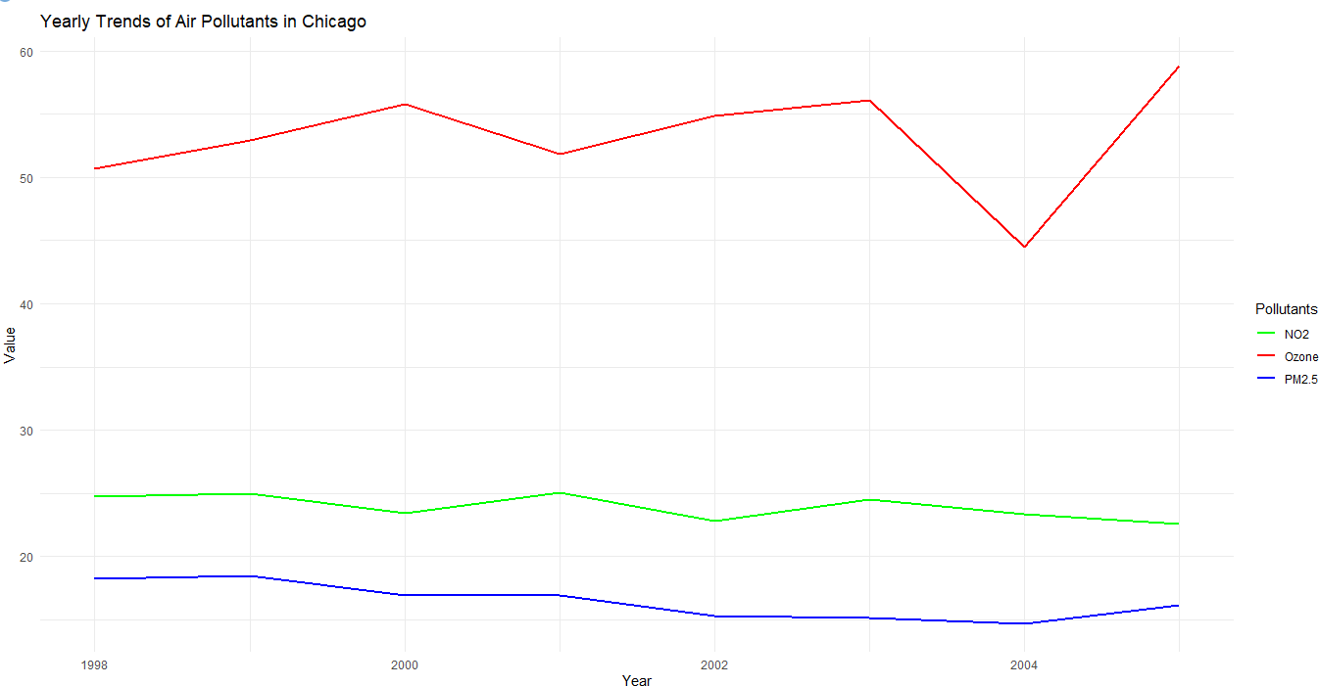
+ x = "Year",
+ y = "Value"
+ ) +
+ scale_color_manual(
+ values = c("PM2.5" = "blue", "Ozone" = "red", "NO2" = "green"),
+ name = "Pollutants"
+ ) +
+ theme_minimal()
- # Save the Filtered Data to File
- cat("\nSaving filtered data to a new file...\n") Saving filtered data to a new file...
- saveRDS(chic.f, "filtered_chicago.rds")
- cat("Filtered data saved as 'filtered_chicago.rds'\n") Filtered data saved as 'filtered_chicago.rds'

Exploratory Data Analysis # Practical No: 2

Name |  | Roll No:
Class | T.Y.B.Sc. Data Science | Seat Number:
Subject / Topic | Exploratory Data Analysis
Topic | Use dplyr Grammar for inbuilt data set car.

Practical No: 2 Use dplyr Grammar for inbuilt data set car.

Code:
# Load necessary library library(dplyr)
# Step 1: Save mtcars dataset as a CSV file (run this once) write.csv(mtcars, "mtcars.csv", row.names = FALSE)
# Step 2: Read the CSV file into R mtcars_data <- read.csv("mtcars.csv") # View the structure of the dataset str(mtcars_data)
# 1. Select specific columns (mpg, cyl, hp) selected_data <- mtcars_data %>% select(mpg, cyl, hp)
# Print selected data print("Selected Data:") print(selected_data)
# 2. Filter rows where mpg > 20 filtered_data <- mtcars_data %>% filter(mpg > 20)
# Print filtered data print("Filtered Data (mpg > 20):") print(filtered_data)
# 3. Arrange rows by horsepower in descending order

arranged_data <- mtcars_data %>% arrange(desc(hp))
# Print arranged data
print("Arranged Data (by hp descending):") print(arranged_data)
# 4. Mutate to add a new column for mpg per cylinder mutated_data <- mtcars_data %>% mutate(mpg_per_cyl = mpg / cyl)
# Print mutated data
print("Mutated Data (with mpg_per_cyl):") print(mutated_data)
# 5. Summarize average mpg by number of cylinders summary_data <- mtcars_data %>%
group_by(cyl) %>%
summarise(avg_mpg = mean(mpg), count = n(), .groups = 'drop') # Print summary data
print("Summary Data (average mpg by cylinder):") print(summary_data)
# 6. Rename the hp column to Horsepower renamed_data <- mtcars_data %>% rename(Horsepower = hp)
# Print renamed data
print("Renamed Data (hp to Horsepower):") print(renamed_data)
# 7. Get distinct values of the number of cylinders distinct_cylinders <- mtcars_data %>% distinct(cyl)
# Print distinct cylinders print("Distinct Values of Cylinders:")

print(distinct_cylinders)
# Example of a complete workflow combining several operations result <- mtcars_data %>%
filter(mpg > 20) %>% select(mpg, cyl, hp) %>% arrange(desc(hp)) %>%
mutate(hp_per_cyl = hp / cyl)
# Print the final result of the complete workflow print("Final Result of Complete Workflow:") print(result)
Output:
- library(dplyr)
- write.csv(mtcars, "mtcars.csv", row.names = FALSE)
- mtcars_data <- read.csv("mtcars.csv")
- str(mtcars_data)
'data.frame': 32 obs. of 11 variables:
$ mpg : num 21 21 22.8 21.4 18.7 18.1 14.3 24.4 22.8 19.2 ...
$ cyl : int 6 6 4 6 8 6 8 4 4 6 ...
$ disp: num 160 160 108 258 360 ...
$ hp : int 110 110 93 110 175 105 245 62 95 123 ...
$ drat: num 3.9 3.9 3.85 3.08 3.15 2.76 3.21 3.69 3.92 3.92 ...
$ wt : num 2.62 2.88 2.32 3.21 3.44 ...
$ qsec: num 16.5 17 18.6 19.4 17 ...
$ vs : int 0 0 1 1 0 1 0 1 1 1 ...
$ am : int 1 1 1 0 0 0 0 0 0 0 ...
$ gear: int 4 4 4 3 3 3 3 4 4 4 ...
$ carb: int 4 4 1 1 2 1 4 2 2 4 ...
- selected_data <- mtcars_data %>%
+ select(mpg, cyl, hp)

- print("Selected Data:")
[1] "Selected Data:"
- print(selected_data) mpg cyl hp

1 21.0 | 6 110
2 21.0 | 6 110
3 22.8 | 4 93
4 21.4 | 6 110
5 18.7 | 8 175
6 18.1 | 6 105
7 14.3 | 8 245
8 24.4 | 4 62
9 22.8 | 4 95
10 19.2 | 6 123
11 17.8 | 6 123
12 16.4 | 8 180
13 17.3 | 8 180
14 15.2 | 8 180
15 10.4 | 8 205
16 10.4 | 8 215
17 14.7 | 8 230
18 32.4 | 4 66
19 30.4 | 4 52
20 33.9 | 4 65
21 21.5 | 4 97
22 15.5 | 8 150
23 15.2 | 8 150
24 13.3 | 8 245
25 19.2 | 8 175

26 27.3 | 4 66
27 26.0 | 4 91
28 30.4 | 4 113
29 15.8 | 8 264
30 19.7 | 6 175
31 15.0 | 8 335
32 21.4 | 4 109
- filtered_data <- mtcars_data %>%
+ filter(mpg > 20)
- print("Filtered Data (mpg > 20):")
[1] "Filtered Data (mpg > 20):"
- print(filtered_data)
mpg cyl disp hp drat wt qsec vs am gear carb

1 21.0 | 6 160.0 110 3.90 2.620 16.46 0 1 |  |  |  |  | 4 | 4
2 21.0 | 6 160.0 110 3.90 2.875 17.02 0 1 |  |  |  |  | 4 | 4
3 22.8 | 4 108.0 93 3.85 2.320 18.61 1 1 |  |  |  |  | 4 | 1
4 21.4 | 6 258.0 110 3.08 3.215 19.44 1 0 |  |  |  |  | 3 | 1
5 24.4 | 4 146.7 62 3.69 3.190 20.00 1 0 |  |  |  |  | 4 | 2
6 22.8 | 4 140.8 95 3.92 3.150 22.90 1 0 |  |  |  |  | 4 | 2
7 32.4 | 4 | 78.7 | 66 4.08 2.200 19.47 | 1 | 1 | 4 | 1
8 30.4 | 4 | 75.7 | 52 4.93 1.615 18.52 | 1 | 1 4 2
9 33.9 | 4 | 71.1 | 65 4.22 1.835 19.90 | 1 | 1 4 1
10 21.5 | 4 120.1 97 3.70 2.465 20.01 1 0 |  |  |  |  | 3 | 1
11 27.3 | 4 79.0 66 4.08 1.935 18.90 1 1 |  |  |  |  | 4 | 1
12 26.0 | 4 120.3 91 4.43 2.140 16.70 0 1 |  |  |  |  | 5 | 2
13 30.4 | 4 95.1 113 3.77 1.513 16.90 1 1 |  |  |  |  | 5 | 2
14 21.4 | 4 121.0 109 4.11 2.780 18.60 1 1 |  |  |  |  | 4 | 2
- arranged_data <- mtcars_data %>%
+ arrange(desc(hp))

- print("Arranged Data (by hp descending):")
[1] "Arranged Data (by hp descending):"
- print(arranged_data)
mpg cyl disp hp drat wt qsec vs am gear carb

1 15.0 | 8 301.0 335 3.54 3.570 14.60 | 0 | 1 | 5 | 8
2 15.8 | 8 351.0 264 4.22 3.170 14.50 | 0 | 1 | 5 | 4
3 14.3 | 8 360.0 245 3.21 3.570 15.84 | 0 | 0 | 3 | 4
4 13.3 | 8 350.0 245 3.73 3.840 15.41 | 0 | 0 | 3 | 4
5 14.7 | 8 440.0 230 3.23 5.345 17.42 | 0 | 0 | 3 | 4
6 10.4 | 8 460.0 215 3.00 5.424 17.82 | 0 | 0 | 3 | 4
7 10.4 | 8 472.0 205 2.93 5.250 17.98 | 0 | 0 | 3 | 4
8 16.4 | 8 275.8 180 3.07 4.070 17.40 | 0 | 0 | 3 | 3
9 17.3 | 8 275.8 180 3.07 3.730 17.60 | 0 | 0 | 3 | 3
10 15.2 | 8 275.8 180 3.07 3.780 18.00 | 0 | 0 | 3 | 3
11 18.7 | 8 360.0 175 3.15 3.440 17.02 | 0 | 0 | 3 | 2
12 19.2 | 8 400.0 175 3.08 3.845 17.05 | 0 | 0 | 3 | 2
13 19.7 | 6 145.0 175 3.62 2.770 15.50 | 0 | 1 | 5 | 6
14 15.5 | 8 318.0 150 2.76 3.520 16.87 | 0 | 0 | 3 | 2
15 15.2 | 8 304.0 150 3.15 3.435 17.30 | 0 | 0 | 3 | 2
16 19.2 | 6 167.6 123 3.92 3.440 18.30 | 1 | 0 | 4 | 4
17 17.8 | 6 167.6 123 3.92 3.440 18.90 | 1 | 0 | 4 | 4
18 30.4 | 4 95.1 113 3.77 1.513 16.90 | 1 | 1 | 5 | 2
19 21.0 | 6 160.0 110 3.90 2.620 16.46 | 0 | 1 | 4 | 4
20 21.0 | 6 160.0 110 3.90 2.875 17.02 | 0 | 1 | 4 | 4
21 21.4 | 6 258.0 110 3.08 3.215 19.44 | 1 | 0 | 3 | 1
22 21.4 | 4 121.0 109 4.11 2.780 18.60 | 1 | 1 | 4 | 2
23 18.1 | 6 225.0 105 2.76 3.460 20.22 | 1 | 0 | 3 | 1
24 21.5 | 4 120.1 97 3.70 2.465 20.01 | 1 | 0 | 3 | 1
25 22.8 | 4 140.8 95 3.92 3.150 22.90 | 1 | 0 | 4 | 2

26 22.8 | 4 108.0 93 3.85 2.320 18.61 1 1 |  |  |  |  | 4 | 1
27 26.0 | 4 120.3 91 4.43 2.140 16.70 0 1 |  |  |  |  | 5 | 2
28 32.4 | 4 | 78.7 | 66 4.08 2.200 19.47 | 1 | 1 | 4 | 1
29 27.3 | 4 | 79.0 | 66 4.08 1.935 18.90 | 1 | 1 | 4 | 1
30 33.9 | 4 | 71.1 | 65 4.22 1.835 19.90 | 1 | 1 | 4 | 1
31 24.4 | 4 146.7 62 3.69 3.190 20.00 1 0 |  |  |  |  | 4 | 2
32 30.4 | 4 75.7 52 4.93 1.615 18.52 1 1 |  |  |  |  | 4 | 2
- mutated_data <- mtcars_data %>%
+ mutate(mpg_per_cyl = mpg / cyl)
- print("Mutated Data (with mpg_per_cyl):")
[1] "Mutated Data (with mpg_per_cyl):"
- print(mutated_data)
mpg cyl disp hp drat wt qsec vs am gear carb mpg_per_cyl

1 21.0 | 6 160.0 110 3.90 2.620 16.46 0 1 |  |  | 4 | 4 | 3.500000
2 21.0 | 6 160.0 110 3.90 2.875 17.02 0 1 |  |  | 4 | 4 | 3.500000
3 22.8 | 4 108.0 93 3.85 2.320 18.61 1 1 |  |  | 4 | 1 | 5.700000
4 21.4 | 6 258.0 110 3.08 3.215 19.44 | 1 | 0 | 3 | 1 | 3.566667
5 18.7 | 8 360.0 175 3.15 3.440 17.02 | 0 | 0 | 3 | 2 | 2.337500
6 18.1 | 6 225.0 105 2.76 3.460 20.22 | 1 | 0 | 3 | 1 | 3.016667
7 14.3 | 8 360.0 245 3.21 3.570 15.84 | 0 | 0 | 3 | 4 | 1.787500
8 24.4 | 4 146.7 62 3.69 3.190 20.00 1 | 0 |  | 4 | 2 | 6.100000
9 22.8 | 4 140.8 95 3.92 3.150 22.90 1 | 0 |  | 4 | 2 | 5.700000
10 19.2 | 6 167.6 123 3.92 3.440 18.30 | 1 | 0 | 4 | 4 | 3.200000
11 17.8 | 6 167.6 123 3.92 3.440 18.90 | 1 | 0 | 4 | 4 | 2.966667
12 16.4 | 8 275.8 180 3.07 4.070 17.40 | 0 | 0 | 3 | 3 | 2.050000
13 17.3 | 8 275.8 180 3.07 3.730 17.60 | 0 | 0 | 3 | 3 | 2.162500
14 15.2 | 8 275.8 180 3.07 3.780 18.00 | 0 | 0 | 3 | 3 | 1.900000
15 10.4 | 8 472.0 205 2.93 5.250 17.98 | 0 | 0 | 3 | 4 | 1.300000
16 10.4 | 8 460.0 215 3.00 5.424 17.82 | 0 | 0 | 3 | 4 | 1.300000

17 14.7 8 440.0 230 3.23 5.345 17.42 0 0 3 4 1.837500

18 32.4 | 4 | 78.7 | 66 4.08 2.200 19.47 | 1 | 1 | 4 | 1 | 8.100000
19 30.4 | 4 | 75.7 | 52 4.93 1.615 18.52 | 1 | 1 | 4 | 2 | 7.600000
20 33.9 | 4 | 71.1 | 65 4.22 1.835 19.90 | 1 | 1 | 4 | 1 | 8.475000
21 21.5 | 4 120.1 97 3.70 2.465 20.01 1 0 |  |  |  |  | 3 | 1 | 5.375000
22 15.5 | 8 318.0 150 2.76 3.520 16.87 |  |  | 0 | 0 | 3 | 2 | 1.937500
23 15.2 | 8 304.0 150 3.15 3.435 17.30 |  |  | 0 | 0 | 3 | 2 | 1.900000
24 13.3 | 8 350.0 245 3.73 3.840 15.41 |  |  | 0 | 0 | 3 | 4 | 1.662500
25 19.2 | 8 400.0 175 3.08 3.845 17.05 |  |  | 0 | 0 | 3 | 2 | 2.400000
26 27.3 | 4 79.0 66 4.08 1.935 18.90 1 1 |  |  |  |  | 4 | 1 | 6.825000
27 26.0 | 4 120.3 91 4.43 2.140 16.70 0 1 |  |  |  |  | 5 | 2 | 6.500000
28 30.4 | 4 95.1 113 3.77 1.513 16.90 1  1 |  |  |  |  | 5 | 2 | 7.600000
29 15.8 | 8 351.0 264 4.22 3.170 14.50 |  |  | 0 | 1 | 5 | 4 | 1.975000
30 19.7 | 6 145.0 175 3.62 2.770 15.50 |  |  | 0 | 1 | 5 | 6 | 3.283333
31 15.0 | 8 301.0 335 3.54 3.570 14.60 |  |  | 0 | 1 | 5 | 8 | 1.875000
32 21.4 | 4 121.0 109 4.11 2.780 18.60 |  |  | 1 | 1 | 4 | 2 | 5.350000
- summary_data <- mtcars_data %>%
+ group_by(cyl) %>%
+ summarise(avg_mpg = mean(mpg), count = n(), .groups = 'drop')
- print("Summary Data (average mpg by cylinder):")
[1] "Summary Data (average mpg by cylinder):"
- print(summary_data) # A tibble: 3 × 3
cyl avg_mpg count
<int> <dbl> <int>
1 4 26.7 11
2 6 19.7 7
3 8 15.1 14
- renamed_data <- mtcars_data %>%

+ rename(Horsepower = hp)
- print("Renamed Data (hp to Horsepower):")
[1] "Renamed Data (hp to Horsepower):"
- print(renamed_data)
mpg cyl disp Horsepower drat wt qsec vs am gear carb

1 21.0 | 6 160.0 | 110 3.90 2.620 16.46 0 1 |  |  | 4 | 4
2 21.0 | 6 160.0 | 110 3.90 2.875 17.02 0 1 |  |  | 4 | 4
3 22.8 | 4 108.0 | 93 3.85 2.320 18.61 1 1 |  |  | 4 | 1
4 21.4 | 6 258.0 | 110 3.08 3.215 19.44 | 1 | 0 | 3 | 1
5 18.7 | 8 360.0 | 175 3.15 3.440 17.02 | 0 | 0 | 3 | 2
6 18.1 | 6 225.0 | 105 2.76 3.460 20.22 | 1 | 0 | 3 | 1
7 14.3 | 8 360.0 | 245 3.21 3.570 15.84 | 0 | 0 | 3 | 4

8 24.4 | 4 146.7 |  | 62 3.69 3.190 20.00 1 |  | 0 | 4 | 2
9 22.8 | 4 140.8 |  | 95 3.92 3.150 22.90 1 |  | 0 | 4 | 2
10 19.2 | 6 167.6 |  | 123 3.92 3.440 18.30 | 1 | 0 | 4 | 4
11 17.8 | 6 167.6 |  | 123 3.92 3.440 18.90 | 1 | 0 | 4 | 4
12 16.4 | 8 275.8 |  | 180 3.07 4.070 17.40 | 0 | 0 | 3 | 3
13 17.3 | 8 275.8 |  | 180 3.07 3.730 17.60 | 0 | 0 | 3 | 3
14 15.2 | 8 275.8 |  | 180 3.07 3.780 18.00 | 0 | 0 | 3 | 3
15 10.4 | 8 472.0 |  | 205 2.93 5.250 17.98 | 0 | 0 | 3 | 4
16 10.4 | 8 460.0 |  | 215 3.00 5.424 17.82 | 0 | 0 | 3 | 4
17 14.7 | 8 440.0 |  | 230 3.23 5.345 17.42 | 0 | 0 | 3 | 4
18 32.4 | 4 | 78.7 | 66 4.08 2.200 19.47 | 1 | 1 | 4 | 1
19 30.4 | 4 | 75.7 | 52 4.93 1.615 18.52 | 1 | 1 | 4 | 2
20 33.9 | 4 | 71.1 | 65 4.22 1.835 19.90 | 1 | 1 | 4 | 1

21 21.5 | 4 120.1 | 97 3.70 2.465 20.01 1 0 |  | 3 | 1
22 15.5 | 8 318.0 | 150 2.76 3.520 16.87 | 0 | 0 | 3 | 2
23 15.2 | 8 304.0 | 150 3.15 3.435 17.30 | 0 | 0 | 3 | 2
24 13.3 | 8 350.0 | 245 3.73 3.840 15.41 | 0 | 0 | 3 | 4

25 19.2 | 8 400.0 | 175 3.08 3.845 17.05 0 0 3 2
26 27.3 | 4 79.0 | 66 4.08 1.935 18.90 1 1 |  | 4 | 1
27 26.0 | 4 120.3 | 91 4.43 2.140 16.70 0 1 |  | 5 | 2
28 30.4 | 4 95.1 | 113 3.77 1.513 16.90 1 1 |  | 5 | 2
29 15.8 | 8 351.0 | 264 4.22 3.170 14.50 | 0 | 1 | 5 | 4
30 19.7 | 6 145.0 | 175 3.62 2.770 15.50 | 0 | 1 | 5 | 6
31 15.0 | 8 301.0 | 335 3.54 3.570 14.60 | 0 | 1 | 5 | 8
32 21.4 | 4 121.0 | 109 4.11 2.780 18.60 | 1 | 1 | 4 | 2
- distinct_cylinders <- mtcars_data %>%
+ distinct(cyl)
- print("Distinct Values of Cylinders:")
[1] "Distinct Values of Cylinders:"
- print(distinct_cylinders) cyl
1 6
2 4
3 8
- result <- mtcars_data %>%
+ filter(mpg > 20) %>%
+ select(mpg, cyl, hp) %>%
+ arrange(desc(hp)) %>%
+ mutate(hp_per_cyl = hp / cyl)
- print("Final Result of Complete Workflow:")
[1] "Final Result of Complete Workflow:"
- print(result)
mpg cyl hp hp_per_cyl

1 30.4 | 4 113 | 28.25000
2 21.0 | 6 110 | 18.33333
3 21.0 | 6 110 | 18.33333

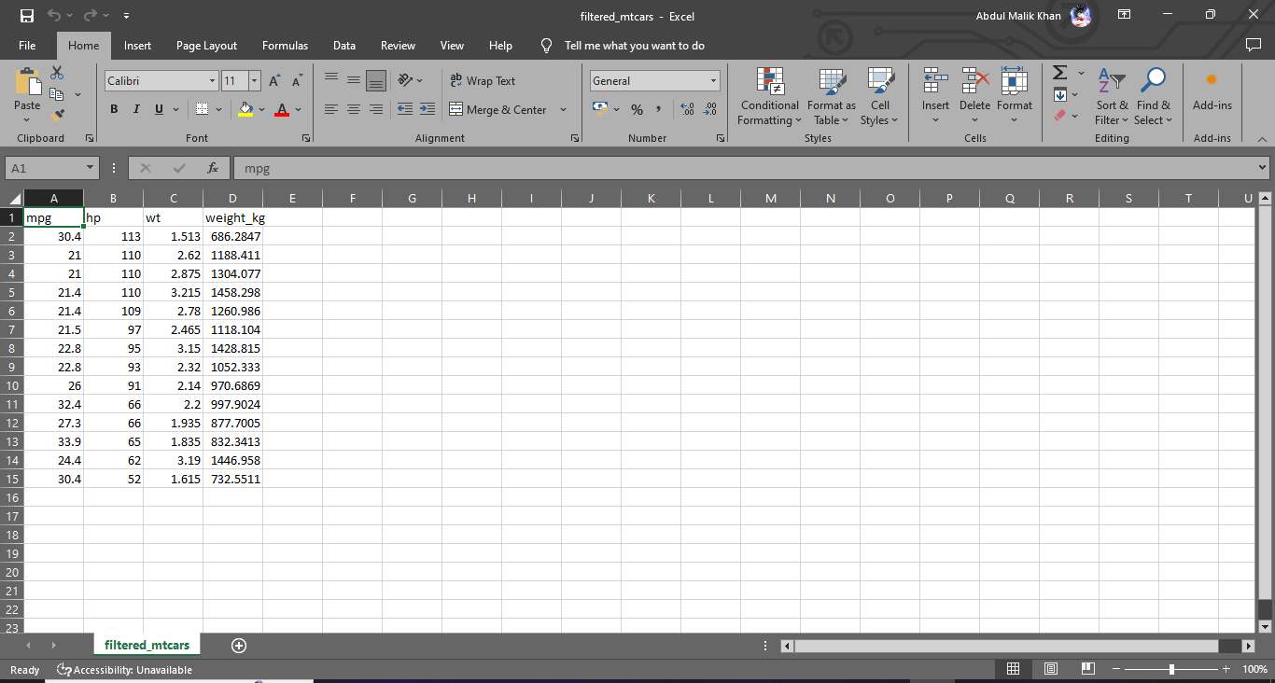
4 21.4 | 6 110 18.33333
5 21.4 | 4 109 27.25000
6 21.5 | 4 | 97 | 24.25000
7 22.8 | 4 | 95 | 23.75000
8 22.8 | 4 | 93 | 23.25000
9 26.0 | 4 | 91 | 22.75000
10 32.4 | 4 | 66 | 16.50000
11 27.3 | 4 | 66 | 16.50000
12 33.9 | 4 | 65 | 16.25000
13 24.4 | 4 | 62 | 15.50000
14 30.4 | 4 | 52 | 13.00000
After Running Program, we can see filtered_mtcars.csv file

Exploratory Data Analysis # Practical No: 3

Name |  | Roll No: | Type your text
Class | T.Y.B.Sc. Data Science | Seat Number:
Subject / Topic | Exploratory Data Analysis
Topic | Use group by(), %>%,mutate(), rename(),arrange(), filter(), select()

Practical No: 3 Use group by(), %>%,mutate(), rename(),arrange(), filter(), select().

Code:
# Managing Data Frames with the dplyr Package and Visualizing with ggplot2 # Load necessary libraries
library(dplyr) # For data manipulation library(ggplot2) # For data visualization library(tidyr) # For handling missing values # Using the starwars dataset
data("starwars")
# 1. Filter: Select only characters with height greater than 180 tall_characters <- starwars %>%
filter(height > 180, !is.na(height), !is.na(mass)) # Remove NAs
# 2. Select: Choose specific columns (name, height, mass, species) tall_characters_selected <- tall_characters %>%
select(name, height, mass, species)
# 3. Mutate: Create a new column for BMI (Body Mass Index) tall_characters_bmi <- tall_characters_selected %>% mutate(bmi = mass / (height/100)^2)
# 4. Rename: Change the column name 'mass' to 'weight' tall_characters_renamed <- tall_characters_bmi %>% rename(weight = mass)
# 5. Arrange: Sort by BMI in descending order

sorted_tall_characters <- tall_characters_renamed %>% arrange(desc(bmi))
# 6. Group By: Group by species and summarize average BMI
average_bmi_by_species <- sorted_tall_characters %>% group_by(species) %>%
summarise(avg_bmi = mean(bmi, na.rm = TRUE)) %>%
arrange(desc(avg_bmi)) # Sorting for better visualization # Display the final result
print(average_bmi_by_species)
# 1. Bar Plot: Average BMI by Species
ggplot(average_bmi_by_species, aes(x = reorder(species, -avg_bmi), y = avg_bmi, fill = species)) + geom_bar(stat = "identity") +
coord_flip() + # Flip coordinates for better readability
labs(title = "Average BMI by Species", x = "Species", y = "Average BMI") + theme_minimal() +
theme(legend.position = "none") # Hide legend for clarity # 2. Scatter Plot: Height vs Weight with BMI Color Scale
ggplot(sorted_tall_characters, aes(x = height, y = weight, color = bmi)) +
geom_point(size = 4, alpha = 0.7) +
scale_color_gradient(low = "blue", high = "red") +
labs(title = "Height vs Weight with BMI Scale", x = "Height (cm)", y = "Weight (kg)", color = "BMI") + theme_minimal()
# 3. Box Plot: BMI Distribution by Species ggplot(sorted_tall_characters, aes(x = species, y = bmi, fill = species)) + geom_boxplot() +
coord_flip() + # Flip for better readability
labs(title = "BMI Distribution by Species", x = "Species", y = "BMI") + theme_minimal() +
theme(legend.position = "none") # Hide legend for clarity

Output:
- library(dplyr) # For data manipulation
- library(ggplot2) # For data visualization
- library(tidyr) # For handling missing values
- data("starwars")
- tall_characters <- starwars %>%
+ filter(height > 180, !is.na(height), !is.na(mass))
- tall_characters_selected <- tall_characters %>%
+ select(name, height, mass, species)
- tall_characters_bmi <- tall_characters_selected %>%
+ mutate(bmi = mass / (height/100)^2)
- tall_characters_renamed <- tall_characters_bmi %>%
+ rename(weight = mass)
- sorted_tall_characters <- tall_characters_renamed %>%
+ arrange(desc(bmi))
- average_bmi_by_species <- sorted_tall_characters %>%
+ group_by(species) %>%
+ summarise(avg_bmi = mean(bmi, na.rm = TRUE)) %>%
+ arrange(desc(avg_bmi)) # Sorting for better visualization
- print(average_bmi_by_species) # A tibble: 17 × 2
species avg_bmi
<chr> <dbl>
- Droid 35
- Kaleesh 34.1
- Trandoshan 31.3
- Besalisk 26.0

5 NA | 24.8
6 Neimodian |  | 24.7
7 Geonosian |  | 23.9
8 Human | 23.4
9 Wookiee | 23.2
10 Nautolan | 22.6
11 Kel Dor | 22.6
12 Cerean | 20.9
13 Pau'an | 18.9
14 Kaminoan |  | 16.8
15 Gungan | 16.8
16 Tholothian |  | 14.8
17 Skakoan | 12.9
- ggplot(average_bmi_by_species, aes(x = reorder(species, -avg_bmi), y = avg_bmi, fill = species)) +
+ geom_bar(stat = "identity") +
+ coord_flip() + # Flip coordinates for better readability
+ labs(title = "Average BMI by Species", x = "Species", y = "Average BMI") +
+ theme_minimal() +
+ theme(legend.position = "none") # Hide legend for clarity

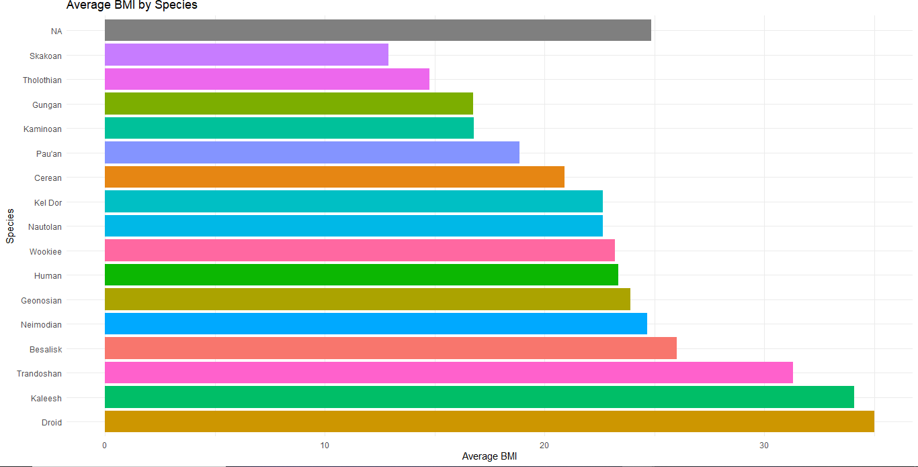
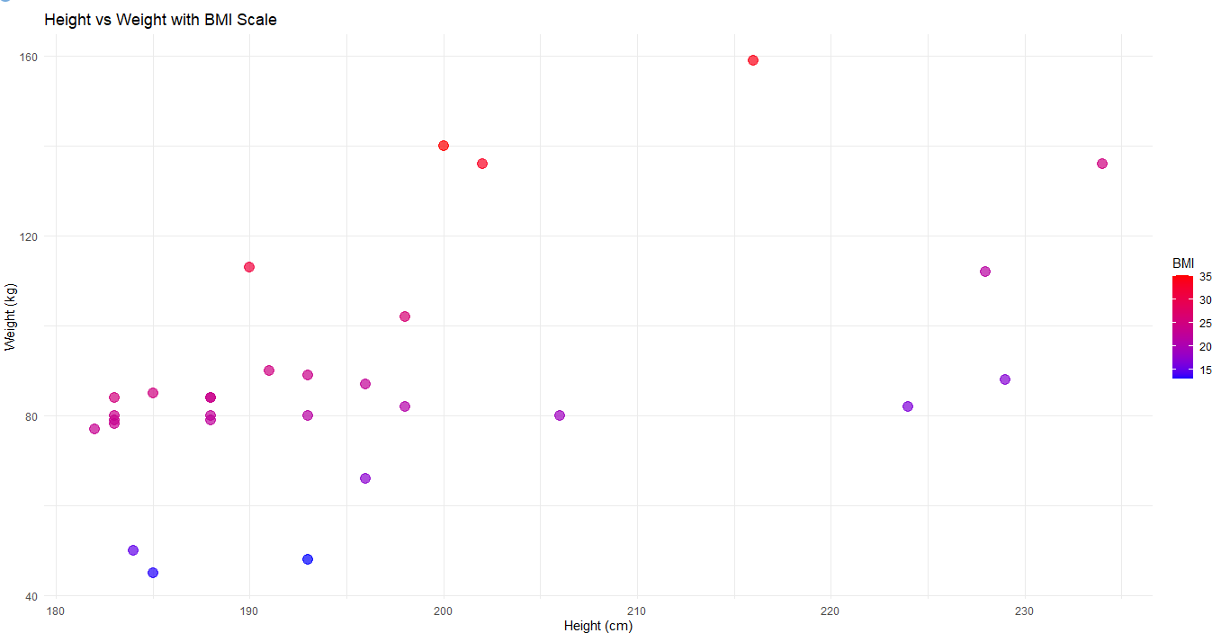

- ggplot(sorted_tall_characters, aes(x = height, y = weight, color = bmi)) +
+ geom_point(size = 4, alpha = 0.7) +
+ scale_color_gradient(low = "blue", high = "red") +
+ labs(title = "Height vs Weight with BMI Scale", x = "Height (cm)", y = "Weight (kg)", color = "BMI") +
+ theme_minimal()

- ggplot(sorted_tall_characters, aes(x = species, y = bmi, fill = species)) +
+ geom_boxplot() +
+ coord_flip() + # Flip for better readability

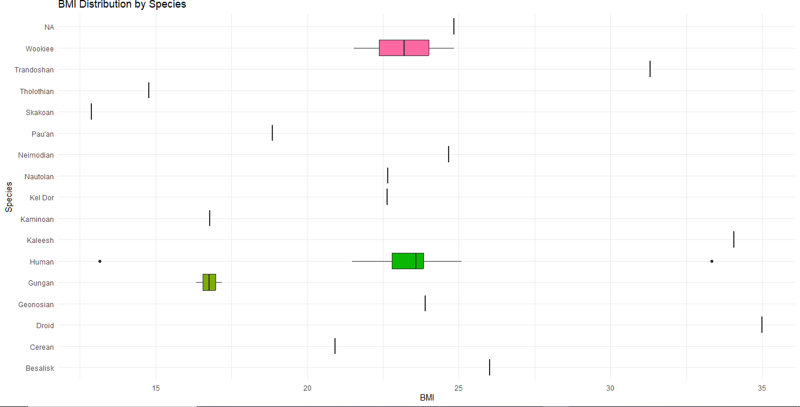
+ labs(title = "BMI Distribution by Species", x = "Species", y = "BMI") +
+ theme_minimal() +
+ theme(legend.position = "none") # Hide legend for clarity

Exploratory Data Analysis # Practical No: 4

Name |  | Roll No: | 46
Class | T.Y.B.Sc. Data Science | Seat Number:
Subject / Topic | Exploratory Data Analysis
Topic | Use the data set air quality from inbuilt data sets library.

Practical No: 4 Use the data set air quality from inbuilt data sets library.
4(A)Use summary statistics and find the important key values from the output.
Code:
# Load the airquality dataset data("airquality")
# Check the structure of the dataset str(airquality)
# View the first few rows of the dataset head(airquality)
# Generate summary statistics for the entire dataset summary_stats <- summary(airquality) print(summary_stats)
# Check for missing values in each column
missing_values <- colSums(is.na(airquality)) print(missing_values)
# Handling missing values by removing rows with NA values cleaned_data <- na.omit(airquality)
# Generate summary statistics for the cleaned data summary_cleaned_stats <- summary(cleaned_data) print(summary_cleaned_stats)
# Optional: Visualize the data using pairs plot to see relationships
library(graphics)
pairs(cleaned_data, panel = panel.smooth, main = "Air Quality Data Relationships")

# Optional: Fit a linear model to explore relationships between variables fit <- lm(Ozone ~ Wind + Solar.R + Temp, data = cleaned_data) summary(fit)
Output:
- data("airquality")
- str(airquality)
'data.frame': 153 obs. of 6 variables:
$ Ozone : int 41 36 12 18 NA 28 23 19 8 NA ...
$ Solar.R: int 190 118 149 313 NA NA 299 99 19 194 ...
$ Wind : num 7.4 8 12.6 11.5 14.3 14.9 8.6 13.8 20.1 8.6 ...
$ Temp : int 67 72 74 62 56 66 65 59 61 69 ...
$ Month : int 5 5 5 5 5 5 5 5 5 5 ...
$ Day : int 1 2 3 4 5 6 7 8 9 10 ...
- head(airquality)
Ozone Solar.R Wind Temp Month Day

1 41 | 190 7.4 67 |  | 5 1
2 36 | 118 8.0 72 |  | 5 2
3 12 | 149 12.6 | 74 | 5 | 3
4 18 | 313 11.5 | 62 | 5 | 4
5 NA | NA 14.3 | 56 | 5 | 5
6 28 | NA 14.9 | 66 | 5 | 6
- summary_stats <- summary(airquality)
- print(summary_stats)
Ozone Solar.R Wind Temp Month
Min. : 1.00 Min. : 7.0 Min. : 1.700 Min. :56.00 Min. :5.000
1st Qu.: 18.00 1st Qu.:115.8 1st Qu.: 7.400 1st Qu.:72.00 1st Qu.:6.000
Median : 31.50 Median :205.0 Median : 9.700 Median :79.00 Median :7.000
Mean : 42.13 Mean :185.9 Mean : 9.958 Mean :77.88 Mean :6.993 3rd Qu.: 63.25 3rd Qu.:258.8 3rd Qu.:11.500 3rd Qu.:85.00 3rd Qu.:8.000

Max. :168.00 Max. :334.0 Max. :20.700 Max. :97.00 Max. :9.000
NA's :37 NA's :7
Day Min. : 1.0
1st Qu.: 8.0
Median :16.0
Mean :15.8 3rd Qu.:23.0 Max. :31.0

- missing_values <- colSums(is.na(airquality))
- print(missing_values)
Ozone Solar.R Wind Temp Month Day
37 7 0 0 0 0
- cleaned_data <- na.omit(airquality)
- summary_cleaned_stats <- summary(cleaned_data)
- print(summary_cleaned_stats)
Ozone Solar.R Wind Temp Month
Min. : 1.0 Min. : 7.0 Min. : 2.30 Min. :57.00 Min. :5.000
1st Qu.: 18.0 1st Qu.:113.5 1st Qu.: 7.40 1st Qu.:71.00 1st Qu.:6.000
Median : 31.0 Median :207.0 Median : 9.70 Median :79.00 Median :7.000
Mean : 42.1 Mean :184.8 Mean : 9.94 Mean :77.79 Mean :7.216 3rd Qu.: 62.0 3rd Qu.:255.5 3rd Qu.:11.50 3rd Qu.:84.50 3rd Qu.:9.000 Max. :168.0 Max. :334.0 Max. :20.70 Max. :97.00 Max. :9.000
Day Min. : 1.00
1st Qu.: 9.00
Median :16.00
Mean :15.95

3rd Qu.:22.50 Max. :31.00
- library(graphics)
- pairs(cleaned_data, panel = panel.smooth, main = "Air Quality Data Relationships")
- fit <- lm(Ozone ~ Wind + Solar.R + Temp, data = cleaned_data)
- summary(fit)

Call:
lm(formula = Ozone ~ Wind + Solar.R + Temp, data = cleaned_data)

Residuals:
Min 1Q Median 3Q Max
-40.485 -14.219 -3.551 10.097 95.619

Coefficients:
Estimate Std. Error t value Pr(>|t|) (Intercept) -64.34208 23.05472 -2.791 0.00623 **

Wind | -3.33359 | 0.65441 | -5.094 1.52e-06 ***
Solar.R | 0.05982 | 0.02319 | 2.580 0.01124 *
Temp | 1.65209 | 0.25353 | 6.516 2.42e-09 ***
---
Signif. codes: 0 ‘***’ 0.001 ‘**’ 0.01 ‘*’ 0.05 ‘.’ 0.1 ‘ ’ 1

Residual standard error: 21.18 on 107 degrees of freedom Multiple R-squared: 0.6059, Adjusted R-squared: 0.5948 F-statistic: 54.83 on 3 and 107 DF, p-value: < 2.2e-16

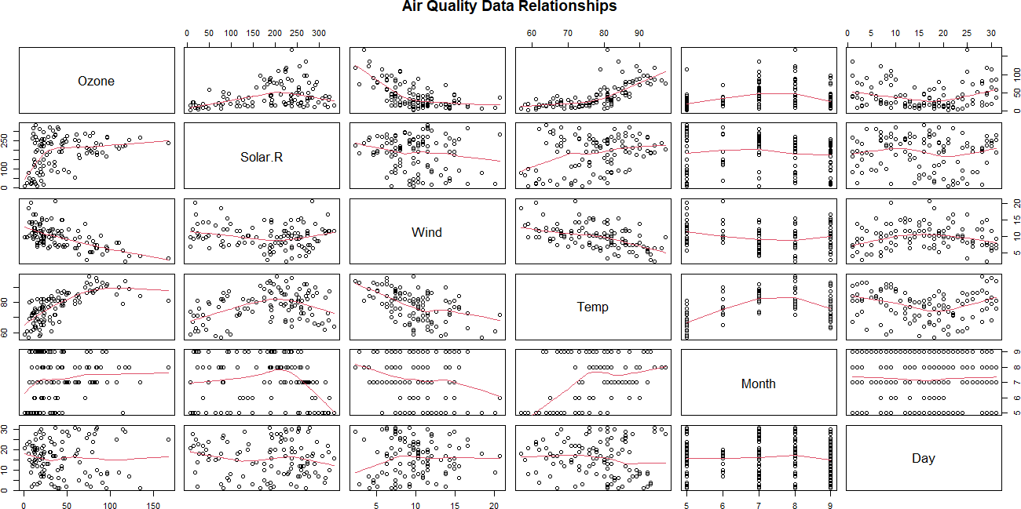

4(B) Use boxplot and find the interquartile range. Interpret the boxplot and inner and outer fencing of outliers.
Code:
# Load the airquality dataset airquality <- datasets::airquality

# Display the first and last 6 rows of the dataset cat("First 6 rows of the dataset:\n") print(head(airquality))

cat("\nLast 6 rows of the dataset:\n") print(tail(airquality))

# Summary statistics for Ozone cat("\nSummary Statistics for Ozone:\n") summary_ozone <- summary(airquality$Ozone) print(summary_ozone)

# Create a boxplot for Ozone levels boxplot(airquality$Ozone,
main = "Boxplot of Ozone Levels", ylab = "Ozone (ppb)",
col = "lightblue", border = "darkblue")

# Calculate Interquartile Range (IQR)
IQR_ozone <- IQR(airquality$Ozone, na.rm = TRUE) cat("\nInterquartile Range (IQR):", IQR_ozone, "\n")

# Calculate Q1 and Q3
Q1 <- quantile(airquality$Ozone, 0.25, na.rm = TRUE) Q3 <- quantile(airquality$Ozone, 0.75, na.rm = TRUE)

# Calculate inner and outer fences for outliers inner_fence_low <- Q1 - 1.5 * IQR_ozone inner_fence_high <- Q3 + 1.5 * IQR_ozone

cat("\nInner Fence Low:", inner_fence_low, "\n") cat("Inner Fence High:", inner_fence_high, "\n")

# Identify outliers using INNER fences (to get meaningful results) outliers <- airquality$Ozone[!is.na(airquality$Ozone) &
(airquality$Ozone < inner_fence_low | airquality$Ozone > inner_fence_high)]
if (length(outliers) > 0) { cat("\nDetected Outliers:\n") print(outliers)
} else {
cat("\nNo outliers detected based on inner fences.\n")
}

# Optional: Visualize the boxplot with outliers marked boxplot(airquality$Ozone,
main = "Boxplot of Ozone Levels with Outliers", ylab = "Ozone (ppb)",
col = "lightblue", border = "darkblue",
outline = TRUE) # This automatically shows outliers

Output:
- airquality <- datasets::airquality
- cat("First 6 rows of the dataset:\n") First 6 rows of the dataset:
- print(head(airquality))
Ozone Solar.R Wind Temp Month Day

1 41 | 190 7.4 67 |  | 5 1
2 36 | 118 8.0 72 |  | 5 2
3 12 | 149 12.6 | 74 | 5 | 3
4 18 | 313 11.5 | 62 | 5 | 4
5 NA | NA 14.3 | 56 | 5 | 5
6 28 | NA 14.9 | 66 | 5 | 6
- cat("\nLast 6 rows of the dataset:\n")

Last 6 rows of the dataset:
- print(tail(airquality))
Ozone Solar.R Wind Temp Month Day
148 14 20 16.6 63 9 25
149 30 193 6.9 70 9 26
150 NA 145 13.2 77 9 27
151 14 191 14.3 75 9 28
152 18 131 8.0 76 9 29
153 20 223 11.5 68 9 30
- cat("\nSummary Statistics for Ozone:\n")

Summary Statistics for Ozone:
- summary_ozone <- summary(airquality$Ozone)
- print(summary_ozone)
Min. 1st Qu. Median Mean 3rd Qu. Max. NA's

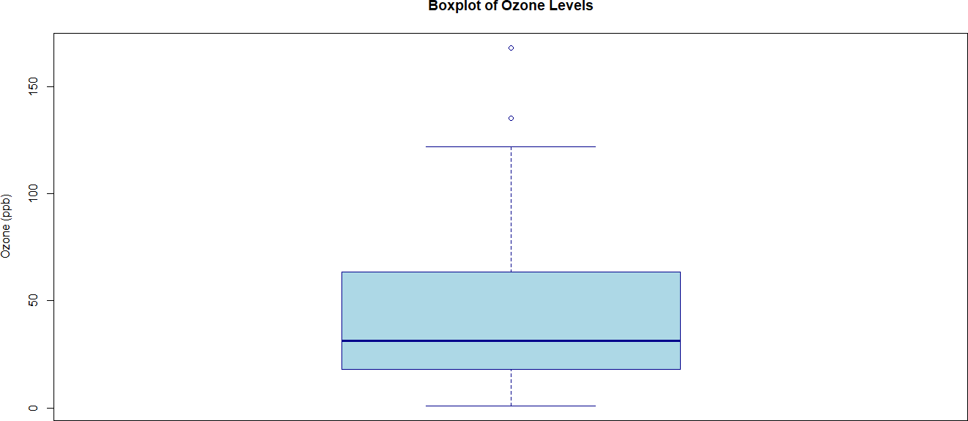
1.00 18.00 31.50 42.13 63.25 168.00 37
- boxplot(airquality$Ozone,
+ main = "Boxplot of Ozone Levels",
+ ylab = "Ozone (ppb)",
+ col = "lightblue",
+ border = "darkblue")

  - IQR_ozone <- IQR(airquality$Ozone, na.rm = TRUE)
  - cat("\nInterquartile Range (IQR):", IQR_ozone, "\n")

Interquartile Range (IQR): 45.25
  - Q1 <- quantile(airquality$Ozone, 0.25, na.rm = TRUE)
  - Q3 <- quantile(airquality$Ozone, 0.75, na.rm = TRUE)
  - inner_fence_low <- Q1 - 1.5 * IQR_ozone
  - inner_fence_high <- Q3 + 1.5 * IQR_ozone
  - cat("\nInner Fence Low:", inner_fence_low, "\n")

Inner Fence Low: -49.875
  - cat("Inner Fence High:", inner_fence_high, "\n") Inner Fence High: 131.125

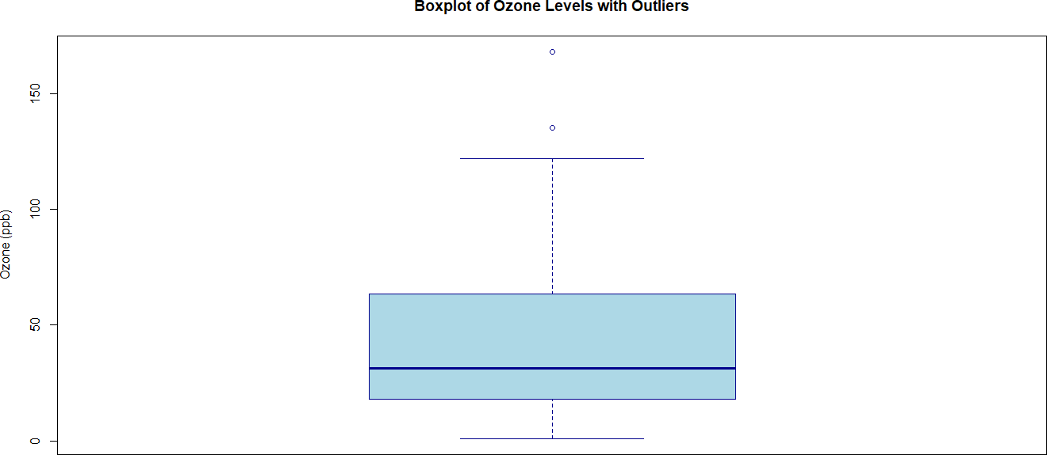
  - outliers <- airquality$Ozone[!is.na(airquality$Ozone) &
+ (airquality$Ozone < inner_fence_low | airquality$Ozone > inner_fence_high)]
  - if (length(outliers) > 0) {
+ cat("\nDetected Outliers:\n")
+ print(outliers)
+ } else {
+ cat("\nNo outliers detected based on inner fences.\n")
+ }

Detected Outliers:
[1] 135 168
  - boxplot(airquality$Ozone,
+ main = "Boxplot of Ozone Levels with Outliers",
+ ylab = "Ozone (ppb)",
+ col = "lightblue",
+ border = "darkblue",
+ outline = TRUE) # This automatically shows outliers

4(C) Check the missing value in the data set and fine the suitable solution for the missing values.
Code:
# Load the airquality dataset airquality <- datasets::airquality

# Check for missing values in the dataset missing_values <- is.na(airquality) cat("Missing Values in the Dataset:\n") print(missing_values)

# Count total missing values in the entire dataset total_missing <- sum(missing_values) cat("\nTotal Missing Values:", total_missing, "\n")

# Count missing values by column missing_by_column <- colSums(missing_values) cat("\nMissing Values by Column:\n") print(missing_by_column)

# Load required libraries library(ggplot2) library(reshape2)

# Prepare data for missing value visualization
missing_data <- as.data.frame(missing_values) # Convert to dataframe missing_data$Row <- seq_len(nrow(missing_data)) # Add row index melted_missing <- melt(missing_data, id.vars = "Row")

# Create a heatmap to visualize missing values ggplot(melted_missing, aes(x = variable, y = Row, fill = value)) + geom_tile(color = "white") +
scale_fill_manual(values = c("TRUE" = "red", "FALSE" = "green"), name = "Missing") + labs(title = "Missing Values Heatmap", x = "Columns", y = "Rows") + theme_minimal()

# Handling missing values
# Option 1: Remove rows with any missing values cleaned_data_remove_na <- na.omit(airquality)
cat("\nNumber of rows after removing NAs:", nrow(cleaned_data_remove_na), "\n")

# Option 2: Impute missing values with mean (for numeric columns) imputed_data_mean <- airquality
for (col in names(imputed_data_mean)) {
if (is.numeric(imputed_data_mean[[col]])) {
imputed_data_mean[[col]][is.na(imputed_data_mean[[col]])] <- mean(imputed_data_mean[[col]], na.rm = TRUE)
}
}

# Summary of imputed data
cat("\nSummary of Data After Mean Imputation:\n") print(summary(imputed_data_mean))
Output:
  - airquality <- datasets::airquality
  - missing_values <- is.na(airquality)
  - cat("Missing Values in the Dataset:\n") Missing Values in the Dataset:

  - print(missing_values)
Ozone Solar.R Wind Temp Month Day [1,] FALSE FALSE FALSE FALSE FALSE FALSE [2,] FALSE FALSE FALSE FALSE FALSE FALSE [3,] FALSE FALSE FALSE FALSE FALSE FALSE [4,] FALSE FALSE FALSE FALSE FALSE FALSE [5,] TRUE TRUE FALSE FALSE FALSE FALSE [6,] FALSE TRUE FALSE FALSE FALSE FALSE [7,] FALSE FALSE FALSE FALSE FALSE FALSE [8,] FALSE FALSE FALSE FALSE FALSE FALSE [9,] FALSE FALSE FALSE FALSE FALSE FALSE
[10,] TRUE FALSE FALSE FALSE FALSE FALSE [11,] FALSE TRUE FALSE FALSE FALSE FALSE [12,] FALSE FALSE FALSE FALSE FALSE FALSE [13,] FALSE FALSE FALSE FALSE FALSE FALSE [14,] FALSE FALSE FALSE FALSE FALSE FALSE [15,] FALSE FALSE FALSE FALSE FALSE FALSE [16,] FALSE FALSE FALSE FALSE FALSE FALSE [17,] FALSE FALSE FALSE FALSE FALSE FALSE [18,] FALSE FALSE FALSE FALSE FALSE FALSE [19,] FALSE FALSE FALSE FALSE FALSE FALSE [20,] FALSE FALSE FALSE FALSE FALSE FALSE [21,] FALSE FALSE FALSE FALSE FALSE FALSE [22,] FALSE FALSE FALSE FALSE FALSE FALSE [23,] FALSE FALSE FALSE FALSE FALSE FALSE [24,] FALSE FALSE FALSE FALSE FALSE FALSE [25,] TRUE FALSE FALSE FALSE FALSE FALSE [26,] TRUE FALSE FALSE FALSE FALSE FALSE [27,] TRUE TRUE FALSE FALSE FALSE FALSE

[28,] | FALSE | FALSE FALSE FALSE FALSE FALSE
[29,] | FALSE | FALSE FALSE FALSE FALSE FALSE
[30,] | FALSE | FALSE FALSE FALSE FALSE FALSE
[31,] | FALSE | FALSE FALSE FALSE FALSE FALSE
[32,] | TRUE | FALSE FALSE FALSE FALSE FALSE
[33,] | TRUE | FALSE FALSE FALSE FALSE FALSE
[34,] | TRUE | FALSE FALSE FALSE FALSE FALSE
[35,] | TRUE | FALSE FALSE FALSE FALSE FALSE
[36,] | TRUE | FALSE FALSE FALSE FALSE FALSE
[37,] | TRUE | FALSE FALSE FALSE FALSE FALSE
[38,] | FALSE | FALSE FALSE FALSE FALSE FALSE
[39,] | TRUE | FALSE FALSE FALSE FALSE FALSE
[40,] | FALSE | FALSE FALSE FALSE FALSE FALSE
[41,] | FALSE | FALSE FALSE FALSE FALSE FALSE
[42,] | TRUE | FALSE FALSE FALSE FALSE FALSE
[43,] | TRUE | FALSE FALSE FALSE FALSE FALSE
[44,] | FALSE | FALSE FALSE FALSE FALSE FALSE
[45,] | TRUE | FALSE FALSE FALSE FALSE FALSE
[46,] | TRUE | FALSE FALSE FALSE FALSE FALSE
[47,] | FALSE | FALSE FALSE FALSE FALSE FALSE
[48,] | FALSE | FALSE FALSE FALSE FALSE FALSE
[49,] | FALSE | FALSE FALSE FALSE FALSE FALSE
[50,] | FALSE | FALSE FALSE FALSE FALSE FALSE
[51,] | FALSE | FALSE FALSE FALSE FALSE FALSE
[52,] | TRUE | FALSE FALSE FALSE FALSE FALSE
[53,] | TRUE | FALSE FALSE FALSE FALSE FALSE
[54,] | TRUE | FALSE FALSE FALSE FALSE FALSE
[55,] | TRUE | FALSE FALSE FALSE FALSE FALSE
[56,] | TRUE | FALSE FALSE FALSE FALSE FALSE

[57,] | TRUE | FALSE FALSE FALSE FALSE FALSE
[58,] | TRUE | FALSE FALSE FALSE FALSE FALSE
[59,] | TRUE | FALSE FALSE FALSE FALSE FALSE
[60,] | TRUE | FALSE FALSE FALSE FALSE FALSE
[61,] | TRUE | FALSE FALSE FALSE FALSE FALSE
[62,] | FALSE | FALSE FALSE FALSE FALSE FALSE
[63,] | FALSE | FALSE FALSE FALSE FALSE FALSE
[64,] | FALSE | FALSE FALSE FALSE FALSE FALSE
[65,] | TRUE | FALSE FALSE FALSE FALSE FALSE
[66,] | FALSE | FALSE FALSE FALSE FALSE FALSE
[67,] | FALSE | FALSE FALSE FALSE FALSE FALSE
[68,] | FALSE | FALSE FALSE FALSE FALSE FALSE
[69,] | FALSE | FALSE FALSE FALSE FALSE FALSE
[70,] | FALSE | FALSE FALSE FALSE FALSE FALSE
[71,] | FALSE | FALSE FALSE FALSE FALSE FALSE
[72,] | TRUE | FALSE FALSE FALSE FALSE FALSE
[73,] | FALSE | FALSE FALSE FALSE FALSE FALSE
[74,] | FALSE | FALSE FALSE FALSE FALSE FALSE
[75,] | TRUE | FALSE FALSE FALSE FALSE FALSE
[76,] | FALSE | FALSE FALSE FALSE FALSE FALSE
[77,] | FALSE | FALSE FALSE FALSE FALSE FALSE
[78,] | FALSE | FALSE FALSE FALSE FALSE FALSE
[79,] | FALSE | FALSE FALSE FALSE FALSE FALSE
[80,] | FALSE | FALSE FALSE FALSE FALSE FALSE
[81,] | FALSE | FALSE FALSE FALSE FALSE FALSE
[82,] | FALSE | FALSE FALSE FALSE FALSE FALSE
[83,] | TRUE | FALSE FALSE FALSE FALSE FALSE
[84,] | TRUE | FALSE FALSE FALSE FALSE FALSE
[85,] | FALSE | FALSE FALSE FALSE FALSE FALSE

[86,] FALSE FALSE FALSE FALSE FALSE FALSE [87,] FALSE FALSE FALSE FALSE FALSE FALSE [88,] FALSE FALSE FALSE FALSE FALSE FALSE [89,] FALSE FALSE FALSE FALSE FALSE FALSE [90,] FALSE FALSE FALSE FALSE FALSE FALSE [91,] FALSE FALSE FALSE FALSE FALSE FALSE [92,] FALSE FALSE FALSE FALSE FALSE FALSE [93,] FALSE FALSE FALSE FALSE FALSE FALSE [94,] FALSE FALSE FALSE FALSE FALSE FALSE [95,] FALSE FALSE FALSE FALSE FALSE FALSE [96,] FALSE TRUE FALSE FALSE FALSE FALSE [97,] FALSE TRUE FALSE FALSE FALSE FALSE [98,] FALSE TRUE FALSE FALSE FALSE FALSE [99,] FALSE FALSE FALSE FALSE FALSE FALSE [100,] FALSE FALSE FALSE FALSE FALSE FALSE [101,] FALSE FALSE FALSE FALSE FALSE FALSE [102,] TRUE FALSE FALSE FALSE FALSE FALSE [103,] TRUE FALSE FALSE FALSE FALSE FALSE [104,] FALSE FALSE FALSE FALSE FALSE FALSE [105,] FALSE FALSE FALSE FALSE FALSE FALSE [106,] FALSE FALSE FALSE FALSE FALSE FALSE [107,] TRUE FALSE FALSE FALSE FALSE FALSE [108,] FALSE FALSE FALSE FALSE FALSE FALSE [109,] FALSE FALSE FALSE FALSE FALSE FALSE [110,] FALSE FALSE FALSE FALSE FALSE FALSE [111,] FALSE FALSE FALSE FALSE FALSE FALSE [112,] FALSE FALSE FALSE FALSE FALSE FALSE [113,] FALSE FALSE FALSE FALSE FALSE FALSE [114,] FALSE FALSE FALSE FALSE FALSE FALSE

[115,] TRUE FALSE FALSE FALSE FALSE FALSE [116,] FALSE FALSE FALSE FALSE FALSE FALSE [117,] FALSE FALSE FALSE FALSE FALSE FALSE [118,] FALSE FALSE FALSE FALSE FALSE FALSE [119,] TRUE FALSE FALSE FALSE FALSE FALSE [120,] FALSE FALSE FALSE FALSE FALSE FALSE [121,] FALSE FALSE FALSE FALSE FALSE FALSE [122,] FALSE FALSE FALSE FALSE FALSE FALSE [123,] FALSE FALSE FALSE FALSE FALSE FALSE [124,] FALSE FALSE FALSE FALSE FALSE FALSE [125,] FALSE FALSE FALSE FALSE FALSE FALSE [126,] FALSE FALSE FALSE FALSE FALSE FALSE [127,] FALSE FALSE FALSE FALSE FALSE FALSE [128,] FALSE FALSE FALSE FALSE FALSE FALSE [129,] FALSE FALSE FALSE FALSE FALSE FALSE [130,] FALSE FALSE FALSE FALSE FALSE FALSE [131,] FALSE FALSE FALSE FALSE FALSE FALSE [132,] FALSE FALSE FALSE FALSE FALSE FALSE [133,] FALSE FALSE FALSE FALSE FALSE FALSE [134,] FALSE FALSE FALSE FALSE FALSE FALSE [135,] FALSE FALSE FALSE FALSE FALSE FALSE [136,] FALSE FALSE FALSE FALSE FALSE FALSE [137,] FALSE FALSE FALSE FALSE FALSE FALSE [138,] FALSE FALSE FALSE FALSE FALSE FALSE [139,] FALSE FALSE FALSE FALSE FALSE FALSE [140,] FALSE FALSE FALSE FALSE FALSE FALSE [141,] FALSE FALSE FALSE FALSE FALSE FALSE [142,] FALSE FALSE FALSE FALSE FALSE FALSE [143,] FALSE FALSE FALSE FALSE FALSE FALSE

[144,] FALSE FALSE FALSE FALSE FALSE FALSE [145,] FALSE FALSE FALSE FALSE FALSE FALSE [146,] FALSE FALSE FALSE FALSE FALSE FALSE [147,] FALSE FALSE FALSE FALSE FALSE FALSE [148,] FALSE FALSE FALSE FALSE FALSE FALSE [149,] FALSE FALSE FALSE FALSE FALSE FALSE [150,] TRUE FALSE FALSE FALSE FALSE FALSE [151,] FALSE FALSE FALSE FALSE FALSE FALSE [152,] FALSE FALSE FALSE FALSE FALSE FALSE [153,] FALSE FALSE FALSE FALSE FALSE FALSE
- total_missing <- sum(missing_values)
- cat("\nTotal Missing Values:", total_missing, "\n")

Total Missing Values: 44
- missing_by_column <- colSums(missing_values)
- cat("\nMissing Values by Column:\n")

Missing Values by Column:
- print(missing_by_column)
Ozone Solar.R Wind Temp Month Day
37 7 0 0 0 0
- library(ggplot2)
- library(reshape2)
- missing_data <- as.data.frame(missing_values) # Convert to dataframe
- missing_data$Row <- seq_len(nrow(missing_data)) # Add row index
- melted_missing <- melt(missing_data, id.vars = "Row")
- ggplot(melted_missing, aes(x = variable, y = Row, fill = value)) +
+ geom_tile(color = "white") +
+ scale_fill_manual(values = c("TRUE" = "red", "FALSE" = "green"), name = "Missing") +

+ labs(title = "Missing Values Heatmap", x = "Columns", y = "Rows") +
+ theme_minimal()
- cleaned_data_remove_na <- na.omit(airquality)
- cat("\nNumber of rows after removing NAs:", nrow(cleaned_data_remove_na), "\n")

Number of rows after removing NAs: 111
- imputed_data_mean <- airquality
- for (col in names(imputed_data_mean)) {
+ if (is.numeric(imputed_data_mean[[col]])) {
+ imputed_data_mean[[col]][is.na(imputed_data_mean[[col]])] <- mean(imputed_data_mean[[col]], na. TRUE)
+ }
+ }
- cat("\nSummary of Data After Mean Imputation:\n")

Summary of Data After Mean Imputation:
- print(summary(imputed_data_mean))
Ozone Solar.R Wind Temp Month
Min. : 1.00 Min. : 7.0 Min. : 1.700 Min. :56.00 Min. :5.000
1st Qu.: 21.00 1st Qu.:120.0 1st Qu.: 7.400 1st Qu.:72.00 1st Qu.:6.000
Median : 42.13 Median :194.0 Median : 9.700 Median :79.00 Median :7.000
Mean : 42.13 Mean :185.9 Mean : 9.958 Mean :77.88 Mean :6.993 3rd Qu.: 46.00 3rd Qu.:256.0 3rd Qu.:11.500 3rd Qu.:85.00 3rd Qu.:8.000 Max. :168.00 Max. :334.0 Max. :20.700 Max. :97.00 Max. :9.000
Day Min. : 1.0
1st Qu.: 8.0
Median :16.0
Mean :15.8

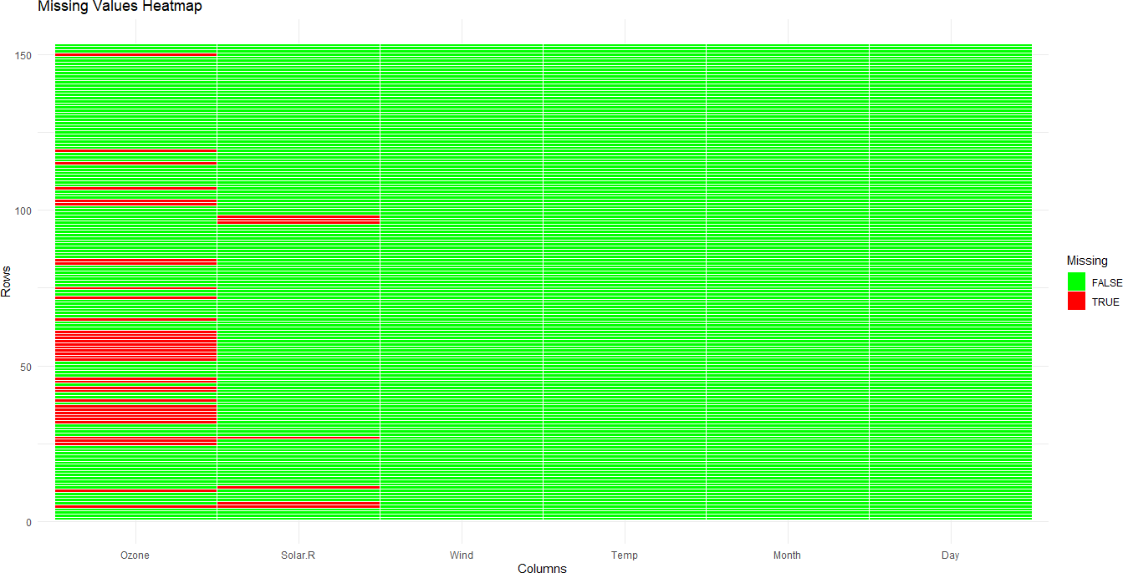
3rd Qu.:23.0 Max. :31.0

4(D) Using histogram, find the distribution of data and give proper comment over the dataset.
Code:
# Load the airquality dataset airquality <- datasets::airquality
# Remove missing values from numeric columns before plotting histograms
airquality_clean <- na.omit(airquality) # Create a histogram for Ozone levels hist(airquality_clean$Ozone,
main = "Histogram of Ozone Levels", xlab = "Ozone (ppb)",
ylab = "Frequency", col = "lightblue", border = "darkblue", breaks = 10)
# Create a histogram for Temperature levels
hist(airquality_clean$Temp,
main = "Histogram of Temperature Levels", xlab = "Temperature (°F)",
ylab = "Frequency", col = "lightgreen", border = "darkgreen", breaks = 10)
# Create a histogram for Solar Radiation levels hist(airquality_clean$Solar.R,
main = "Histogram of Solar Radiation Levels",
xlab = "Solar Radiation (lang)", ylab = "Frequency",
col = "lightcoral",

border = "darkred", breaks = 10)
# Create a histogram for Wind levels
hist(airquality_clean$Wind,
main = "Histogram of Wind Levels", xlab = "Wind Speed (mph)",
ylab = "Frequency", col = "lightyellow",
border = "darkorange", breaks = 10)
# Comments based on the histograms
cat("\nComments on the Dataset:\n")
cat("1. The histogram of Ozone levels indicates a right-skewed distribution,\n") cat(" suggesting that higher ozone levels are less frequent.\n")
cat("2. The Temperature histogram appears to be roughly normal,\n") cat(" indicating typical summer weather patterns in New York.\n")
cat("3. The Solar Radiation histogram shows many days with low radiation,\n") cat(" suggesting variability in weather conditions.\n")
cat("4. The Wind Speed histogram indicates that most days have low wind speeds,\n") cat(" which is common in urban settings.\n")
Output:
- airquality <- datasets::airquality
- airquality_clean <- na.omit(airquality)
- hist(airquality_clean$Ozone,
+ main = "Histogram of Ozone Levels",
+ xlab = "Ozone (ppb)",
+ ylab = "Frequency",
+ col = "lightblue",
+ border = "darkblue",

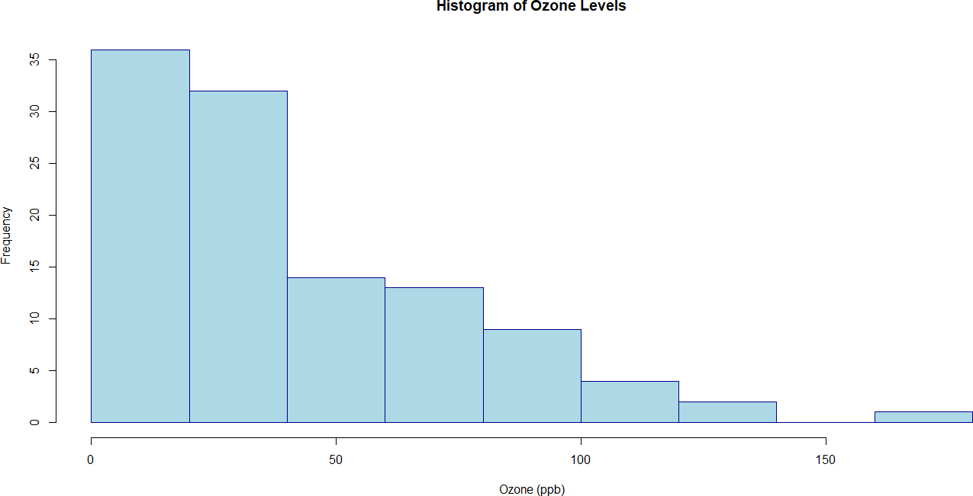
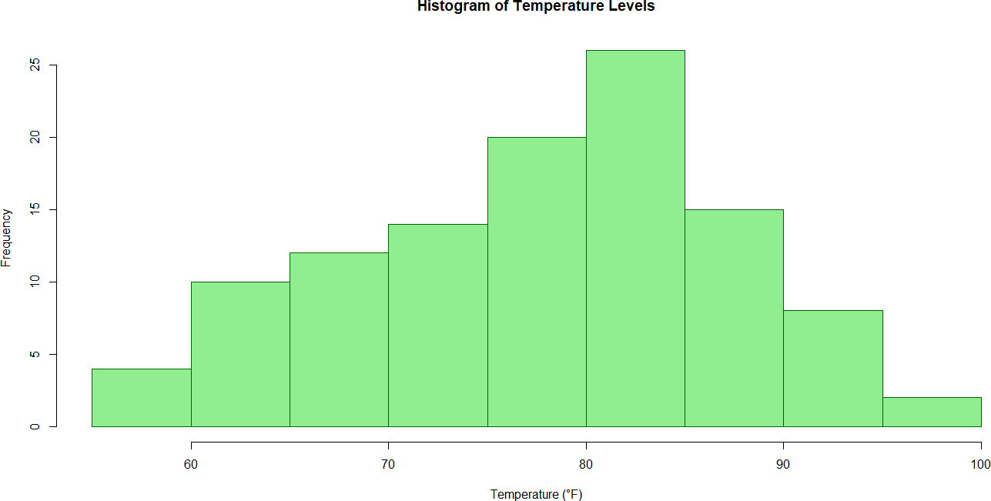
+ breaks = 10)

- hist(airquality_clean$Temp,
+ main = "Histogram of Temperature Levels",
+ xlab = "Temperature (°F)",
+ ylab = "Frequency",
+ col = "lightgreen",
+ border = "darkgreen",
+ breaks = 10)

- hist(airquality_clean$Solar.R,

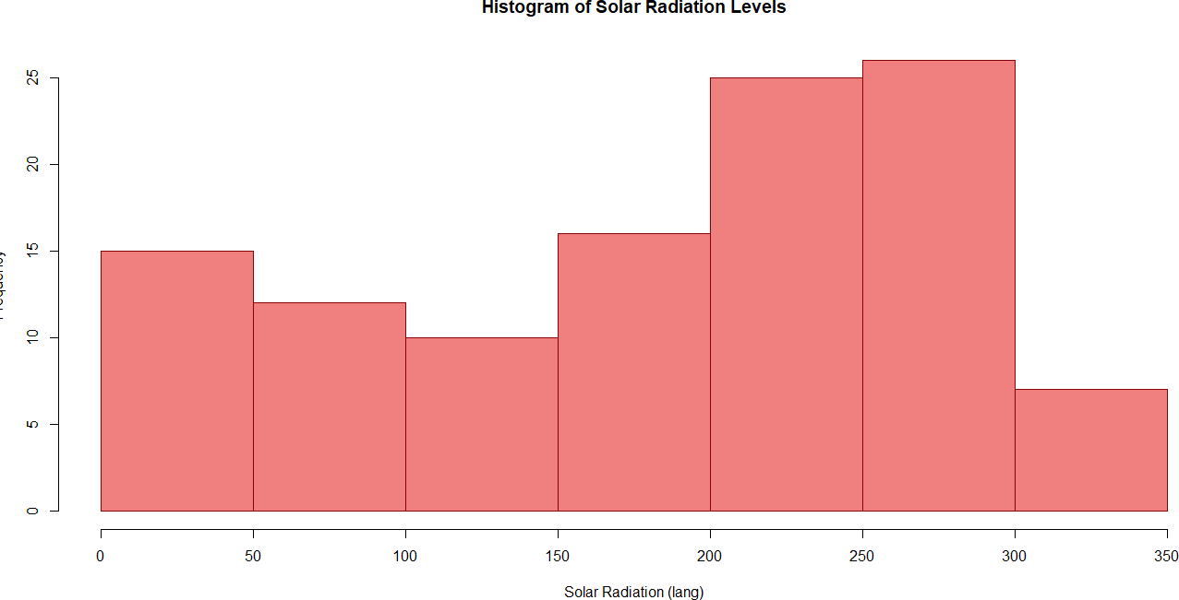
+ main = "Histogram of Solar Radiation Levels",
+ xlab = "Solar Radiation (lang)",
+ ylab = "Frequency",
+ col = "lightcoral",
+ border = "darkred",
+ breaks = 10)

- hist(airquality_clean$Wind,
+ main = "Histogram of Wind Levels",
+ xlab = "Wind Speed (mph)",
+ ylab = "Frequency",
+ col = "lightyellow",
+ border = "darkorange",
+ breaks = 10)

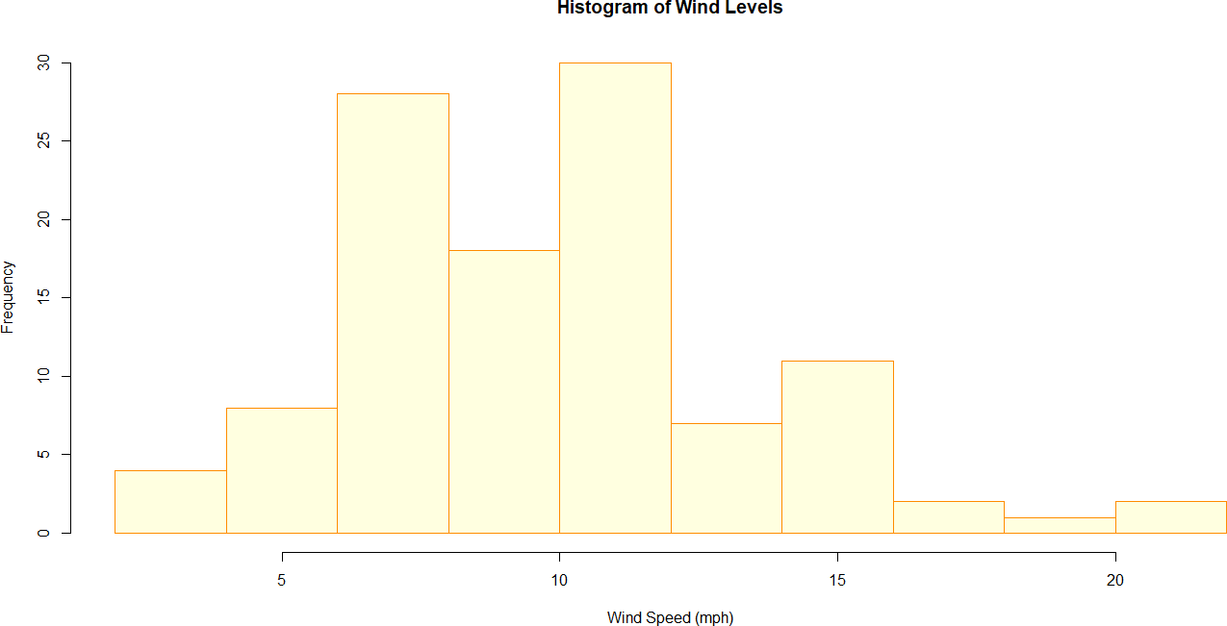

- cat("\nComments on the Dataset:\n") Comments on the Dataset:
- cat("1. The histogram of Ozone levels indicates a right-skewed distribution,\n")
- The histogram of Ozone levels indicates a right-skewed distribution,
  - cat(" suggesting that higher ozone levels are less frequent.\n") suggesting that higher ozone levels are less frequent.
  - cat("2. The Temperature histogram appears to be roughly normal,\n")
- The Temperature histogram appears to be roughly normal,
  - cat(" indicating typical summer weather patterns in New York.\n") indicating typical summer weather patterns in New York.
  - cat("3. The Solar Radiation histogram shows many days with low radiation,\n")
- The Solar Radiation histogram shows many days with low radiation,
  - cat(" suggesting variability in weather conditions.\n") suggesting variability in weather conditions.
  - cat("4. The Wind Speed histogram indicates that most days have low wind speeds,\n")
- The Wind Speed histogram indicates that most days have low wind speeds,
  - cat(" which is common in urban settings.\n") which is common in urban settings.

Exploratory Data Analysis # Practical No: 5

Name |  | Roll No:
Class | T.Y.B.Sc. Data Science | Seat Number:
Subject / Topic | Exploratory Data Analysis
Topic | Use bar plot and identify the difference between bar plot and histograms.  Conclude the appropriate use of bar plot and histogram.

Practical No: 5 Use bar plot and identify the difference between bar plot and histograms. Conclude the appropriate use of bar plot and histogram.
Code:
# Load necessary libraries library(ggplot2) library(dplyr)

# Set working directory (change the path accordingly)
setwd("D:/Sem 6 Practicals/EDA Practical") # Replace with your actual path

# Read the dataset
data <- read.csv("sales_data_sample.csv", stringsAsFactors = FALSE)

# Display the first few rows of the dataset head(data)

# Check for missing values in key columns missing_sales <- sum(is.na(data$SALES))
missing_productline <- sum(is.na(data$PRODUCTLINE))

cat("Missing values in SALES:", missing_sales, "\n")
cat("Missing values in PRODUCTLINE:", missing_productline, "\n")

# Filter out rows with missing SALES or PRODUCTLINE cleaned_data <- data %>%
filter(!is.na(SALES) & !is.na(PRODUCTLINE)) %>%
mutate(PRODUCTLINE = as.factor(PRODUCTLINE)) # Ensure PRODUCTLINE is a factor

# Create a bar plot for total sales by product category bar_plot <- cleaned_data %>% group_by(PRODUCTLINE) %>%
summarise(Total_Sales = sum(SALES, na.rm = TRUE)) %>%
ggplot(aes(x = reorder(PRODUCTLINE, -Total_Sales), y = Total_Sales, fill = PRODUCTLINE)) + geom_bar(stat = "identity") +
labs(title = "Total Sales by Product Category", x = "Product Category", y = "Total Sales") + theme_minimal() +
theme(axis.text.x = element_text(angle = 45, hjust = 1)) # Rotate x-axis labels for readability

# Print the bar plot print(bar_plot)

# Create a histogram for sales amount
histogram <- ggplot(cleaned_data, aes(x = SALES)) + geom_histogram(binwidth = 500, fill = "lightblue", color = "black") +
labs(title = "Distribution of Sales Amount", x = "Sales Amount", y = "Frequency") + theme_minimal()

# Print the histogram print(histogram)

Output:

- library(ggplot2)
- library(dplyr)
- setwd("D:/Sem 6 Practicals/EDA Practical") # Replace with your actual path
- data <- read.csv("sales_data_sample.csv", stringsAsFactors = FALSE)

- head(data)
ORDERNUMBER QUANTITYORDERED PRICEEACH ORDERLINENUMBER ORDERDATE STATUS

SALES

1 | 10107 | 30 | 95.70 | 2 2871.00 | 2/24/2003 0:00 Shipped
2 | 10121 | 34 | 81.35 | 5 2765.90 | 5/7/2003 0:00 Shipped
3 | 10134 | 41 | 94.74 | 2 3884.34 | 7/1/2003 0:00 Shipped
4 | 10145 | 45 | 83.26 | 6 3746.70 | 8/25/2003 0:00 Shipped
5 | 10159 | 49 | 100.00 | 14 5205.27 10/10/2003 0:00 Shipped
6 | 10168 | 36 | 96.66 | 1 3479.76 10/28/2003 0:00 Shipped

QTR_ID MONTH_ID YEAR_ID PRODUCTLINE MSRP PRODUCTCODE
- 1 2 2003 Motorcycles 95 S10_1678 Land of Toys Inc.
- 2 5 2003 Motorcycles 95 S10_1678 Reims Collectables
- 3 7 2003 Motorcycles 95 S10_1678 Lyon Souveniers
- 3 8 2003 Motorcycles 95 S10_1678 Toys4GrownUps.com
- 4 10 2003 Motorcycles 95 S10_1678 Corporate Gift Ideas Co.
- 4 10 2003 Motorcycles 95 S10_1678 Technics Stores Inc. PHONE ADDRESSLINE1 ADDRESSLINE2 CITY STATE
- 2125557818 897 Long Airport Avenue NYC NY
2 26.47.1555 59 rue de l'Abbaye Reims
3 +33 1 46 62 7555 27 rue du Colonel Pierre Avia Paris
CUSTOMERNAME

4 | 6265557265 | 78934 Hillside Dr. | Pasadena | CA
5 | 6505551386 | 7734 Strong St. | San Francisco | CA
6 | 6505556809 | 9408 Furth Circle | Burlingame | CA
POSTALCODE COUNTRY TERRITORY CONTACTLASTNAME CONTACTFIRSTNAME DEALSIZE
- 10022 USA <NA> Yu Kwai Small
- 51100 France EMEA Henriot Paul Small

- 75508 France EMEA
- 90003 USA <NA>
Da Cunha Daniel Medium Young Julie Medium

- USA <NA> Brown Julie Medium

- 94217 USA <NA> Hirano
- missing_sales <- sum(is.na(data$SALES))
Juri Medium

- missing_productline <- sum(is.na(data$PRODUCTLINE))
- cat("Missing values in SALES:", missing_sales, "\n") Missing values in SALES: 0
- cat("Missing values in PRODUCTLINE:", missing_productline, "\n") Missing values in PRODUCTLINE: 0
- cleaned_data <- data %>%
+ filter(!is.na(SALES) & !is.na(PRODUCTLINE)) %>%
+ mutate(PRODUCTLINE = as.factor(PRODUCTLINE)) # Ensure PRODUCTLINE is a factor
- bar_plot <- cleaned_data %>%
+ group_by(PRODUCTLINE) %>%
+ summarise(Total_Sales = sum(SALES, na.rm = TRUE)) %>%
+ ggplot(aes(x = reorder(PRODUCTLINE, -Total_Sales), y = Total_Sales, fill = PRODUCTLINE))
+
+ geom_bar(stat = "identity") +
+ labs(title = "Total Sales by Product Category", x = "Product Category", y = "Total Sales") +
+ theme_minimal() +
+ theme(axis.text.x = element_text(angle = 45, hjust = 1)) # Rotate x-axis labels for readability
- print(bar_plot)

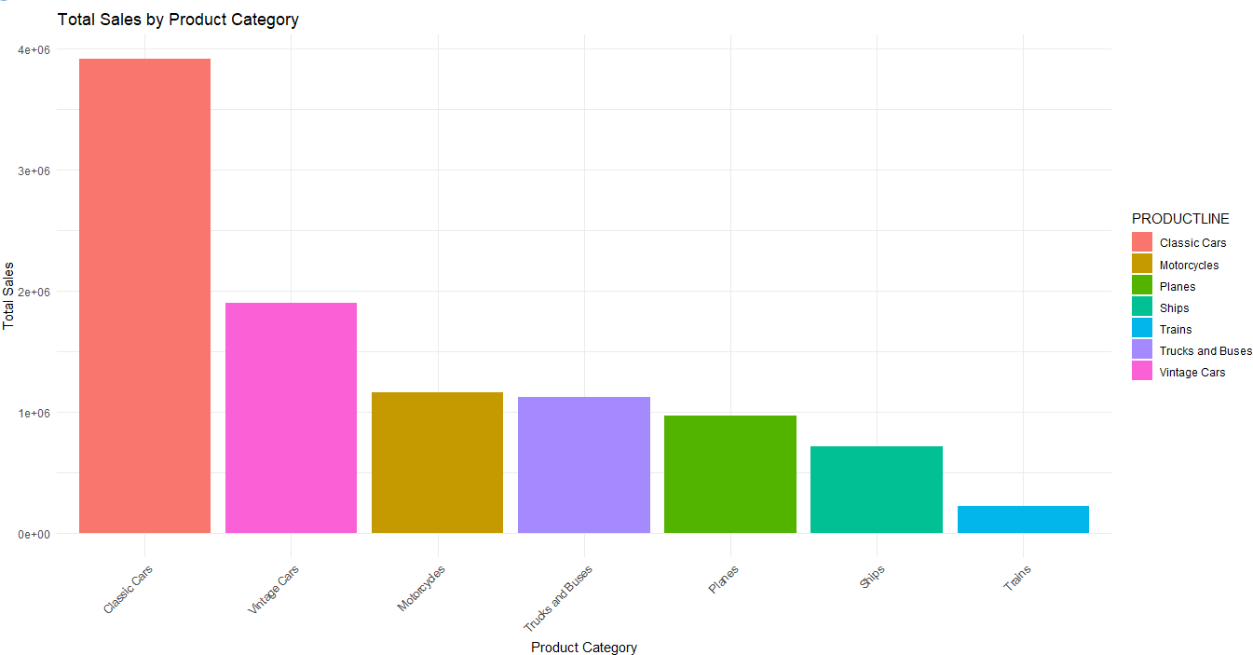
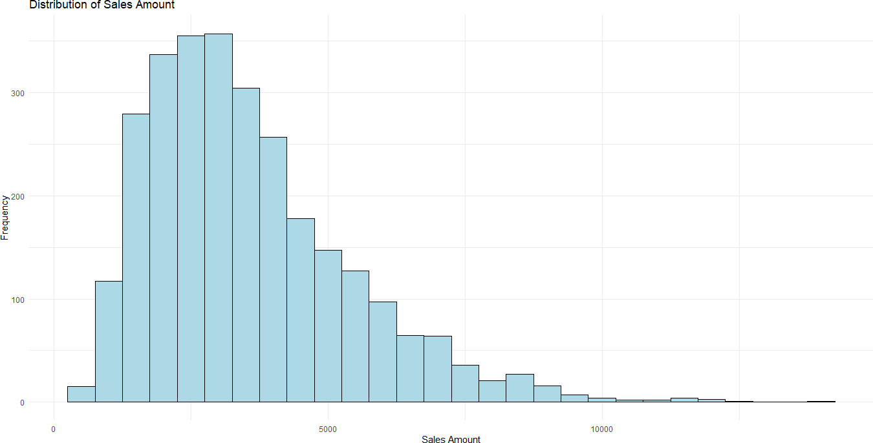

- histogram <- ggplot(cleaned_data, aes(x = SALES)) +
+ geom_histogram(binwidth = 500, fill = "lightblue", color = "black") +
+ labs(title = "Distribution of Sales Amount", x = "Sales Amount", y = "Frequency") +
+ theme_minimal()
- print(histogram)

Exploratory Data Analysis # Practical No: 6

Name |  | Roll No: | Type your text
Class | T.Y.B.Sc. Data Science | Seat Number:
Subject / Topic | Exploratory Data Analysis
Topic | Explore the two dimensional data.

Practical No: 6 Explore the two dimensional data.

Code:
# Load the ChickWeight dataset (built-in) data(ChickWeight)

# 1. Basic Exploration
# View the first few rows of the dataset head(ChickWeight)

# Summary statistics for each column summary(ChickWeight)

# Check the structure of the dataset str(ChickWeight)

# Check for missing values sum(is.na(ChickWeight))

# Unique values in Diet and Chick columns unique(ChickWeight$Diet) unique(ChickWeight$Chick)

# 2. Data Aggregation

# Average weight by diet
mean_weight_by_diet <- aggregate(weight ~ Diet, data=ChickWeight, FUN=mean) print(mean_weight_by_diet)

# Average weight by time
mean_weight_by_time <- aggregate(weight ~ Time, data=ChickWeight, FUN=mean) print(mean_weight_by_time)

# 3. Visualizations
# Load ggplot2 for visualization library(ggplot2)

# Scatter plot: Weight over time, colored by diet ggplot(ChickWeight, aes(x=Time, y=weight, color=Diet)) + geom_point(alpha=0.7) +
geom_smooth(se=FALSE, method="loess") +
labs(title="Weight Over Time by Diet", x="Time (days)", y="Weight (grams)", color="Diet") + theme_minimal()

# Boxplot: Distribution of weight by diet ggplot(ChickWeight, aes(x=Diet, y=weight, fill=Diet)) + geom_boxplot() +
labs(title="Distribution of Chick Weights by Diet", x="Diet", y="Weight (grams)") + theme_minimal()

# Line plot: Weight growth for individual chicks ggplot(ChickWeight, aes(x=Time, y=weight, color=Chick)) + geom_line(aes(group=Chick), alpha=0.7) +
labs(title="Weight Growth for Each Chick", x="Time (days)", y="Weight (grams)") +

theme_minimal() +
theme(legend.position="none") # Hide legend for clarity

# Facet grid: Weight growth trends by diet ggplot(ChickWeight, aes(x=Time, y=weight)) + geom_line(aes(group=Chick, color=Diet)) + facet_wrap(~Diet) +
labs(title="Weight Growth Trends by Diet", x="Time (days)", y="Weight (grams)") +
theme_minimal()

# 4. Statistical Analysis
# ANOVA: Compare weights across diets
anova_model <- aov(weight ~ Diet, data=ChickWeight) summary(anova_model)

# Linear regression: Weight change over time, considering diet lm_model <- lm(weight ~ Time + Diet, data=ChickWeight)
summary(lm_model)

# 5. Check for Outliers
# Boxplot to identify outliers
boxplot(ChickWeight$weight, main="Boxplot of Chick Weights", ylab="Weight")

# Load the ChickWeight dataset (built-in) data(ChickWeight)

# 1. Basic Exploration
# View the first few rows of the dataset head(ChickWeight)

# Summary statistics for each column summary(ChickWeight)

# Check the structure of the dataset str(ChickWeight)

# Check for missing values sum(is.na(ChickWeight))

# Unique values in Diet and Chick columns unique(ChickWeight$Diet) unique(ChickWeight$Chick)

# 2. Data Aggregation
# Average weight by diet
mean_weight_by_diet <- aggregate(weight ~ Diet, data=ChickWeight, FUN=mean) print(mean_weight_by_diet)

# Average weight by time
mean_weight_by_time <- aggregate(weight ~ Time, data=ChickWeight, FUN=mean) print(mean_weight_by_time)

# 3. Visualizations
# Load ggplot2 for visualization library(ggplot2)

# Scatter plot: Weight over time, colored by diet ggplot(ChickWeight, aes(x=Time, y=weight, color=Diet)) +

geom_point(alpha=0.7) + geom_smooth(se=FALSE, method="loess") +
labs(title="Weight Over Time by Diet", x="Time (days)", y="Weight (grams)", color="Diet") +
theme_minimal()

# Boxplot: Distribution of weight by diet ggplot(ChickWeight, aes(x=Diet, y=weight, fill=Diet)) + geom_boxplot() +
labs(title="Distribution of Chick Weights by Diet", x="Diet", y="Weight (grams)") + theme_minimal()

# Line plot: Weight growth for individual chicks ggplot(ChickWeight, aes(x=Time, y=weight, color=Chick)) + geom_line(aes(group=Chick), alpha=0.7) +
labs(title="Weight Growth for Each Chick", x="Time (days)", y="Weight (grams)") + theme_minimal() +
theme(legend.position="none") # Hide legend for clarity

# Facet grid: Weight growth trends by diet ggplot(ChickWeight, aes(x=Time, y=weight)) + geom_line(aes(group=Chick, color=Diet)) + facet_wrap(~Diet) +
labs(title="Weight Growth Trends by Diet", x="Time (days)", y="Weight (grams)") +
theme_minimal()

# 4. Statistical Analysis
# ANOVA: Compare weights across diets
anova_model <- aov(weight ~ Diet, data=ChickWeight) summary(anova_model)

# Linear regression: Weight change over time, considering diet lm_model <- lm(weight ~ Time + Diet, data=ChickWeight) summary(lm_model)

# 5. Check for Outliers
# Boxplot to identify outliers
boxplot(ChickWeight$weight, main="Boxplot of Chick Weights", ylab="Weight")

# Remove outliers using IQR method
Q1 <- quantile(ChickWeight$weight, 0.25, na.rm = TRUE) Q3 <- quantile(ChickWeight$weight, 0.75, na.rm = TRUE)
IQR <- Q3 - Q1

# Remove outliers from the dataset
ChickWeight_clean <- ChickWeight[ChickWeight$weight >= (Q1 - 1.5 * IQR) & ChickWeight$weight <= (Q3 + 1.5 * IQR), ]

# Check the number of rows after removing outliers nrow(ChickWeight_clean) # Number of rows after removing outliers

# Re-plot clean data (Optional)
ggplot(ChickWeight_clean, aes(x = Time, y = weight, color = Diet)) + geom_point(alpha = 0.7) +
geom_smooth(se = FALSE, method = "loess") + labs(title = "Weight Over Time by Diet (Clean Data)",
x = "Time (days)",
y = "Weight (grams)", color = "Diet") +

theme_minimal()
Output:
- data(ChickWeight)
- head(ChickWeight) weight Time Chick Diet
1 42 0 1 1
2 51 2 1 1
3 59 4 1 1
4 64 6 1 1
5 76 8 1 1
6 93 10 1 1
- summary(ChickWeight)
weight Time Chick Diet Min. : 35.0 Min. : 0.00 13 : 12 1:220
1st Qu.: 63.0 1st Qu.: 4.00 9 : 12 2:120
Median :103.0 Median :10.00 20 : 12 3:120
Mean :121.8 Mean :10.72 10 : 12 4:118 3rd Qu.:163.8 3rd Qu.:16.00 17 : 12
Max. :373.0 Max. :21.00 19 : 12
(Other):506

- str(ChickWeight)
Classes ‘nfnGroupedData’, ‘nfGroupedData’, ‘groupedData’ and 'data.frame': 4 variables:

578 obs. of

$ weight: num 42 51 59 64 76 93 106 125 149 171 ...
$ Time : num 0 2 4 6 8 10 12 14 16 18 ...
$ Chick : Ord.factor w/ 50 levels "18"<"16"<"15"<..: 15 15 15 15 15 15 15 15 15 15 ...
$ Diet : Factor w/ 4 levels "1","2","3","4": 1 1 1 1 1 1 1 1 1 1 ...
- attr(*, "formula")=Class 'formula' language weight ~ Time | Chick
.. ..- attr(*, ".Environment")=<environment: R_EmptyEnv>

- attr(*, "outer")=Class 'formula' language ~Diet
.. ..- attr(*, ".Environment")=<environment: R_EmptyEnv>
- attr(*, "labels")=List of 2
..$ x: chr "Time"
..$ y: chr "Body weight"
- attr(*, "units")=List of 2
..$ x: chr "(days)"
..$ y: chr "(gm)"
- sum(is.na(ChickWeight))
[1] 0
- unique(ChickWeight$Diet)
[1] 1 2 3 4
Levels: 1 2 3 4
- unique(ChickWeight$Chick)
[1] 1 2 3 4 5 6 7 8 9 10 11 12 13 14 15 16 17 18 19 20 21 22 23 24 25 26 27 28 29
[30] 30 31 32 33 34 35 36 37 38 39 40 41 42 43 44 45 46 47 48 49 50
50 Levels: 18 < 16 < 15 < 13 < 9 < 20 < 10 < 8 < 17 < 19 < 4 < 6 < 11 < 3 < 1 < ... < 48
- mean_weight_by_diet <- aggregate(weight ~ Diet, data=ChickWeight, FUN=mean)
- print(mean_weight_by_diet) Diet weight
1 1 102.6455
2 2 122.6167
3 3 142.9500
4 4 135.2627
- mean_weight_by_time <- aggregate(weight ~ Time, data=ChickWeight, FUN=mean)
- print(mean_weight_by_time) Time weight
1 0 41.06000
2 2 49.22000

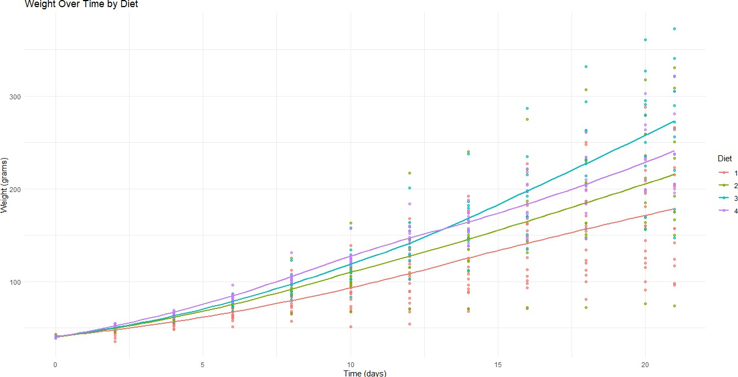
3 4 59.95918
4 6 74.30612
5 8 91.24490
6 10 107.83673
7 12 129.24490
8 14 143.81250
9 16 168.08511
10 18 190.19149
11 20 209.71739
12 21 218.68889
- library(ggplot2)
- ggplot(ChickWeight, aes(x=Time, y=weight, color=Diet)) +
+ geom_point(alpha=0.7) +
+ geom_smooth(se=FALSE, method="loess") +
+ labs(title="Weight Over Time by Diet", x="Time (days)", y="Weight (grams)", color="Diet")
+
+ theme_minimal()
`geom_smooth()` using formula = 'y ~ x'

- ggplot(ChickWeight, aes(x=Diet, y=weight, fill=Diet)) +

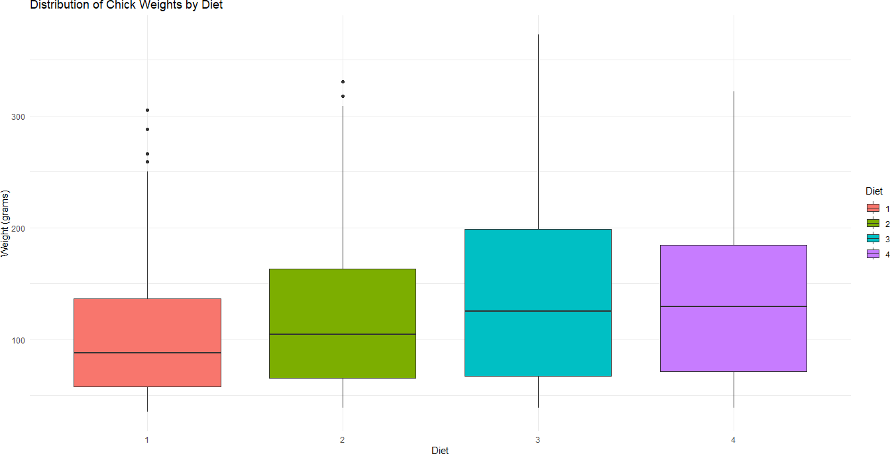
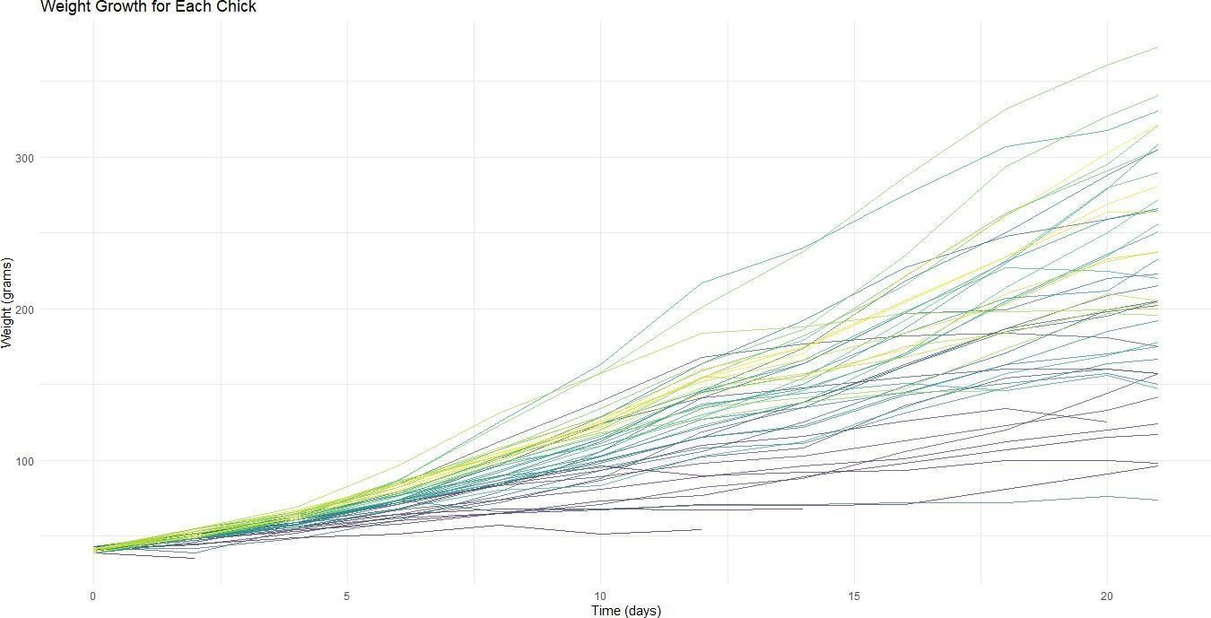
+ geom_boxplot() +
+ labs(title="Distribution of Chick Weights by Diet", x="Diet", y="Weight (grams)") +
+ theme_minimal()

- ggplot(ChickWeight, aes(x=Time, y=weight, color=Chick)) +
+ geom_line(aes(group=Chick), alpha=0.7) +
+ labs(title="Weight Growth for Each Chick", x="Time (days)", y="Weight (grams)") +
+ theme_minimal() +
+ theme(legend.position="none") # Hide legend for clarity

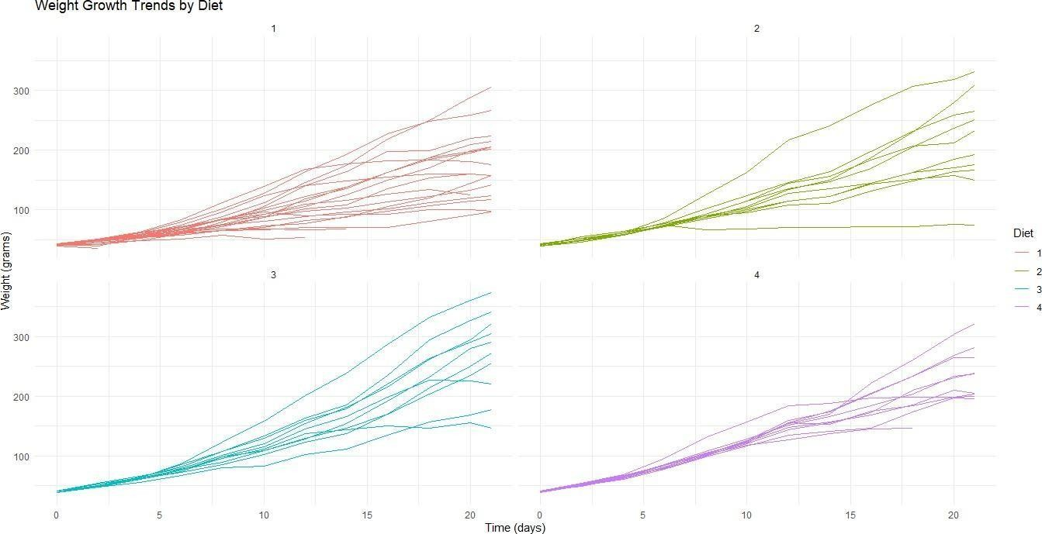
- ggplot(ChickWeight, aes(x=Time, y=weight)) +
+ geom_line(aes(group=Chick, color=Diet)) +
+ facet_wrap(~Diet) +
+ labs(title="Weight Growth Trends by Diet", x="Time (days)", y="Weight (grams)") +
+ theme_minimal()

- anova_model <- aov(weight ~ Diet, data=ChickWeight)
- summary(anova_model)
Df Sum Sq Mean Sq F value Pr(>F)
Diet 3 155863 51954 10.81 6.43e-07 ***
Residuals 574 2758693 4806
---
Signif. codes: 0 ‘***’ 0.001 ‘**’ 0.01 ‘*’ 0.05 ‘.’ 0.1 ‘ ’ 1
- lm_model <- lm(weight ~ Time + Diet, data=ChickWeight)
- summary(lm_model)

Call:
lm(formula = weight ~ Time + Diet, data = ChickWeight)

Residuals:

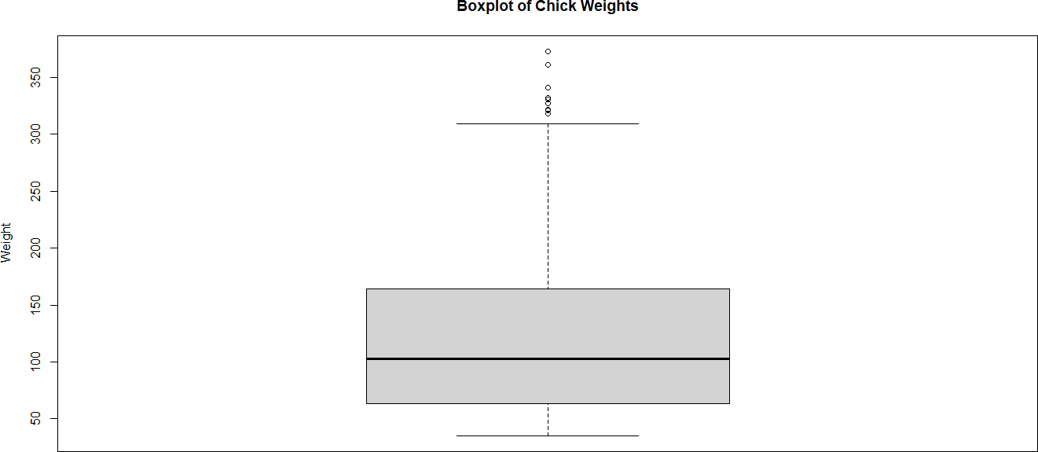
Min 1Q Median 3Q Max
-136.851 -17.151 -2.595 15.033 141.816

Coefficients:
Estimate Std. Error t value Pr(>|t|) (Intercept) 10.9244 3.3607 3.251 0.00122 **
Time 8.7505 0.2218 39.451 < 2e-16 ***

Diet2 | 16.1661 | 4.0858 | 3.957 8.56e-05 ***
Diet3 | 36.4994 | 4.0858 | 8.933 < 2e-16 ***
Diet4 | 30.2335 | 4.1075 | 7.361 6.39e-13 ***
---
Signif. codes: 0 ‘***’ 0.001 ‘**’ 0.01 ‘*’ 0.05 ‘.’ 0.1 ‘ ’ 1

Residual standard error: 35.99 on 573 degrees of freedom Multiple R-squared: 0.7453, Adjusted R-squared: 0.7435 F-statistic: 419.2 on 4 and 573 DF, p-value: < 2.2e-16
- boxplot(ChickWeight$weight, main="Boxplot of Chick Weights", ylab="Weight")

- Q1 <- quantile(ChickWeight$weight, 0.25, na.rm = TRUE)
- Q3 <- quantile(ChickWeight$weight, 0.75, na.rm = TRUE)

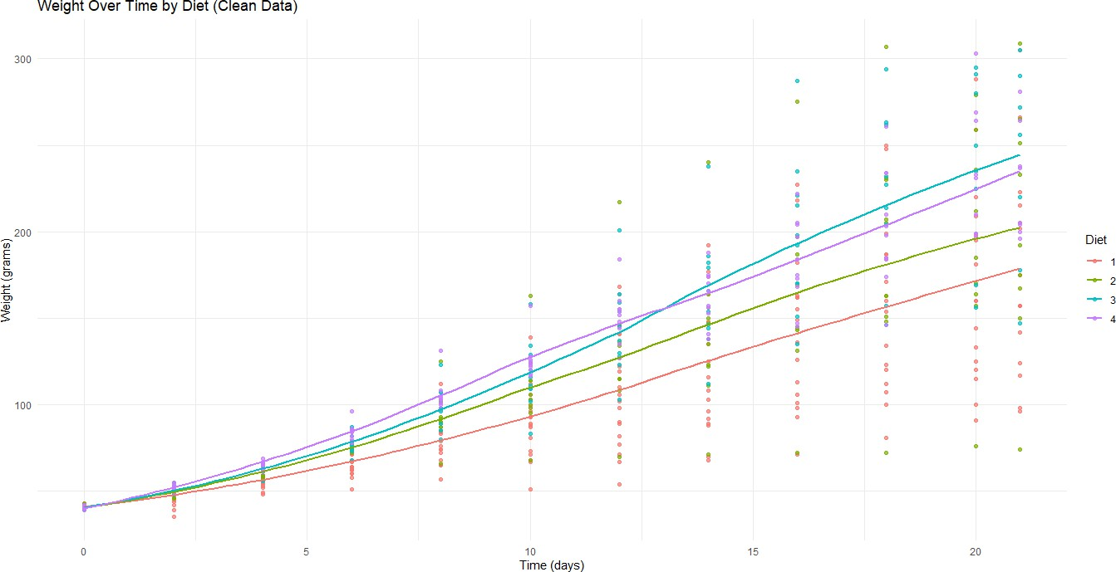
- IQR <- Q3 - Q1
- ChickWeight_clean <- ChickWeight[ChickWeight$weight >= (Q1 - 1.5 * IQR) &
+ ChickWeight$weight <= (Q3 + 1.5 * IQR), ]
- nrow(ChickWeight_clean) # Number of rows after removing outliers
[1] 569
- ggplot(ChickWeight_clean, aes(x = Time, y = weight, color = Diet)) +
+ geom_point(alpha = 0.7) +
+ geom_smooth(se = FALSE, method = "loess") +
+ labs(title = "Weight Over Time by Diet (Clean Data)",
+ x = "Time (days)",
+ y = "Weight (grams)",
+ color = "Diet") +
+ theme_minimal()
`geom_smooth()` using formula = 'y ~ x'

Exploratory Data Analysis # Practical No: 7

Name |  | Roll No: | Type your text  Type your text
Class | T.Y.B.Sc. Data Science | Seat Number:
Subject / Topic | Exploratory Data Analysis
Topic | Scatter plot between two variables.

Practical No: 7 Scatter plot between two variables.

Code:
# Load the ggplot2 package library(ggplot2)

# Load the diamonds dataset (comes with ggplot2) data("diamonds")

# 1. Basic Exploration of the diamonds dataset # View the first few rows of the dataset head(diamonds)

# Summary statistics for the dataset summary(diamonds)

# Check the structure of the dataset str(diamonds)

# 2. Scatter Plot of Price vs Carat using Base R # Scatter plot of price vs. carat plot(diamonds$carat, diamonds$price,
main="Scatter Plot of Price vs Carat", xlab="Carat",

ylab="Price (in USD)", col="blue", pch=16)

# 3. Scatter Plot with Groups using Base R
# Color points by the cut of the diamond (Diamond Cut as factor) plot(diamonds$carat, diamonds$price,
main="Price vs Carat by Diamond Cut", xlab="Carat",
ylab="Price (in USD)", col=as.factor(diamonds$cut), pch=16)

# 4. Scatter Plot using ggplot2 (more advanced) ggplot(data=diamonds, aes(x=carat, y=price)) + geom_point(aes(color=cut), alpha=0.5) + # Color points by 'cut' labs(title="Scatter Plot of Price vs Carat",
x="Carat", y="Price (in USD)", color="Cut") +
theme_minimal()

# 5. Scatter Plot with Regression Line using ggplot2 ggplot(data=diamonds, aes(x=carat, y=price)) + geom_point(aes(color=cut), alpha=0.5) + # Color points by 'cut'
geom_smooth(method="lm", se=FALSE, color="red") + # Add a linear regression line
labs(title="Price vs Carat with Linear Regression Line", x="Carat",
y="Price (in USD)") +
theme_minimal()

# 6. Facet Plot (scatter plot split by cut) ggplot(data=diamonds, aes(x=carat, y=price)) +
geom_point(aes(color=cut), alpha=0.5) + # Color points by 'cut'
facet_wrap(~cut) + # Facet by the cut labs(title="Price vs Carat Faceted by Diamond Cut",
x="Carat",
y="Price (in USD)") + theme_minimal()
Output:
- library(ggplot2)
- data("diamonds")
- head(diamonds) # A tibble: 6 × 10
carat cut color clarity depth table price x y z
<dbl> <ord> <ord> <ord> <dbl> <dbl> <int> <dbl> <dbl> <dbl>
1 0.23 Ideal E SI2 61.5 55 326 3.95 3.98 2.43
2 0.21 Premium E SI1 59.8 61 326 3.89 3.84 2.31
3 0.23 Good E VS1 56.9 65 327 4.05 4.07 2.31
4 0.29 Premium I VS2 62.4 58 334 4.2 4.23 2.63
5 0.31 Good J SI2 63.3 58 335 4.34 4.35 2.75
6 0.24 Very Good J VVS2 62.8 57 336 3.94 3.96 2.48

- summary(diamonds)
carat cut color Min. :0.2000 Fair : 1610

clarity depth
D: 6775 SI1 :13065 Min. :43.00

1st Qu.:0.4000 Good : 4906 E: 9797 VS2 :12258 1st Qu.:61.00
Median :0.7000 Very Good:12082 F: 9542 SI2 : 9194 Median :61.80
Mean :0.7979 Premium :13791 G:11292 VS1 : 8171 Mean :61.75 3rd Qu.:1.0400 Ideal :21551 H: 8304 VVS2 : 5066 3rd Qu.:62.50 Max. :5.0100 I: 5422 VVS1 : 3655 Max. :79.00

J: 2808 (Other): 2531
table price x y z
Min. :43.00 Min. : 326 Min. : 0.000 Min. : 0.000 Min. : 0.000
1st Qu.:56.00 1st Qu.: 950 1st Qu.: 4.710 1st Qu.: 4.720 1st Qu.: 2.910
Median :57.00 Median : 2401 Median : 5.700 Median : 5.710 Median : 3.530
Mean :57.46 Mean : 3933 Mean : 5.731 Mean : 5.735 Mean : 3.539 3rd Qu.:59.00 3rd Qu.: 5324 3rd Qu.: 6.540 3rd Qu.: 6.540 3rd Qu.: 4.040 Max. :95.00 Max. :18823 Max. :10.740 Max. :58.900 Max. :31.800

- str(diamonds)
tibble [53,940 × 10] (S3: tbl_df/tbl/data.frame)
$ carat : num [1:53940] 0.23 0.21 0.23 0.29 0.31 0.24 0.24 0.26 0.22 0.23 ...
$ cut : Ord.factor w/ 5 levels "Fair"<"Good"<..: 5 4 2 4 2 3 3 3 1 3 ...
$ color : Ord.factor w/ 7 levels "D"<"E"<"F"<"G"<..: 2 2 2 6 7 7 6 5 2 5 ...
$ clarity: Ord.factor w/ 8 levels "I1"<"SI2"<"SI1"<..: 2 3 5 4 2 6 7 3 4 5 ...
$ depth : num [1:53940] 61.5 59.8 56.9 62.4 63.3 62.8 62.3 61.9 65.1 59.4 ...
$ table : num [1:53940] 55 61 65 58 58 57 57 55 61 61 ...
$ price : int [1:53940] 326 326 327 334 335 336 336 337 337 338 ...
$ x : num [1:53940] 3.95 3.89 4.05 4.2 4.34 3.94 3.95 4.07 3.87 4 ...
$ y : num [1:53940] 3.98 3.84 4.07 4.23 4.35 3.96 3.98 4.11 3.78 4.05 ...
$ z : num [1:53940] 2.43 2.31 2.31 2.63 2.75 2.48 2.47 2.53 2.49 2.39 ...
- plot(diamonds$carat, diamonds$price,
+ main="Scatter Plot of Price vs Carat",
+ xlab="Carat",
+ ylab="Price (in USD)",
+ col="blue", pch=16)

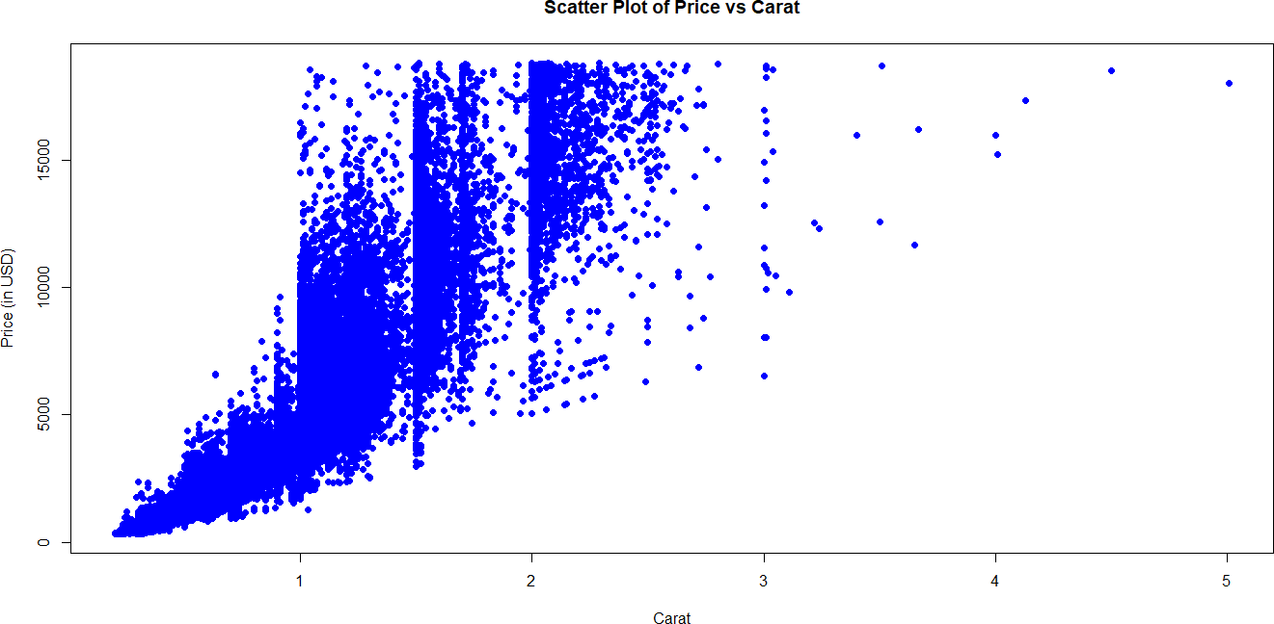
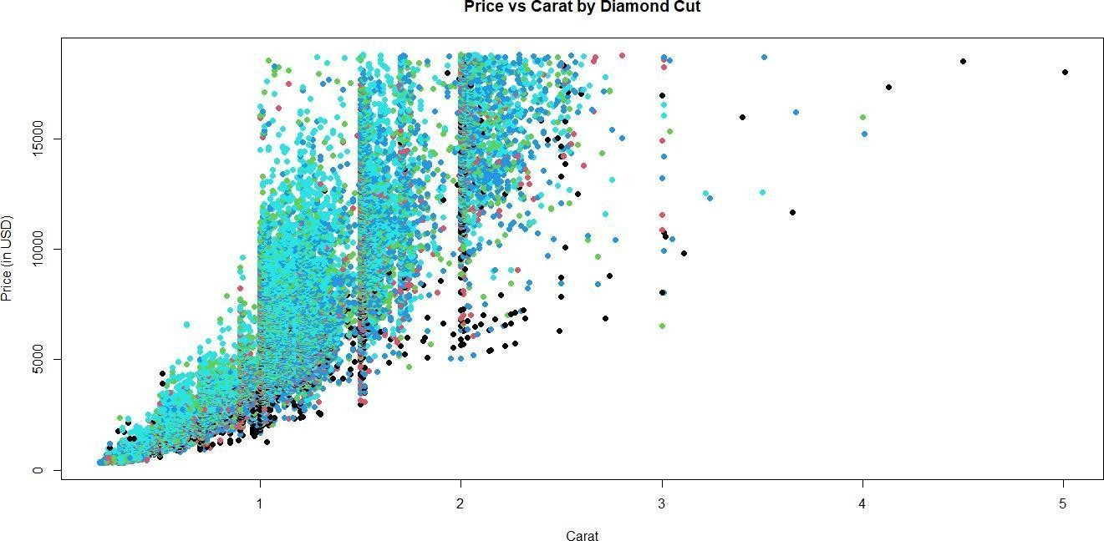

- plot(diamonds$carat, diamonds$price,
+ main="Price vs Carat by Diamond Cut",
+ xlab="Carat",
+ ylab="Price (in USD)",
+ col=as.factor(diamonds$cut), pch=16)

- ggplot(data=diamonds, aes(x=carat, y=price)) +
+ geom_point(aes(color=cut), alpha=0.5) + # Color points by 'cut'
+ labs(title="Scatter Plot of Price vs Carat",
+ x="Carat",

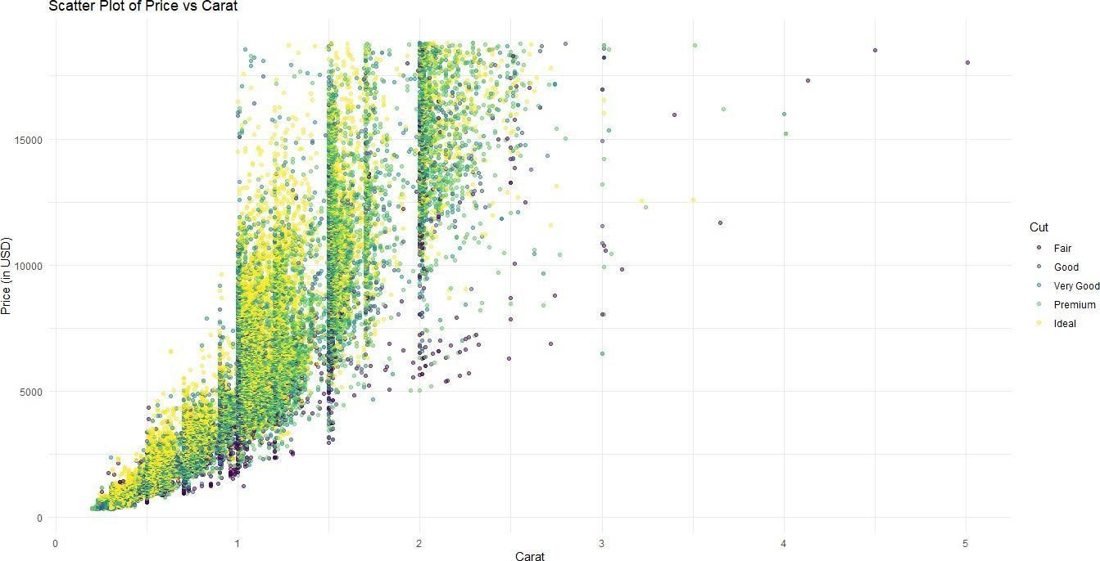
+ y="Price (in USD)",
+ color="Cut") +
+ theme_minimal()

- ggplot(data=diamonds, aes(x=carat, y=price)) +
+ geom_point(aes(color=cut), alpha=0.5) + # Color points by 'cut'
+ geom_smooth(method="lm", se=FALSE, color="red") + # Add a linear regression line
+ labs(title="Price vs Carat with Linear Regression Line",
+ x="Carat",
+ y="Price (in USD)") +
+ theme_minimal()
`geom_smooth()` using formula = 'y ~ x'

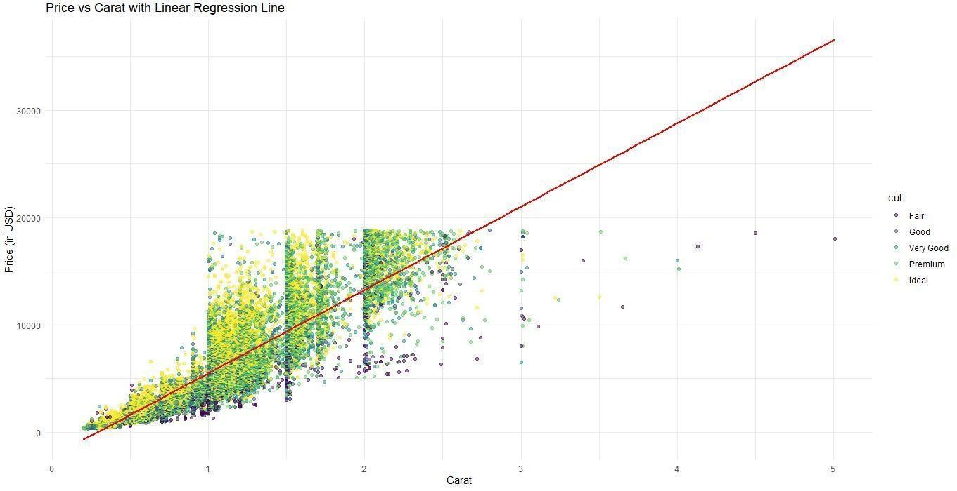
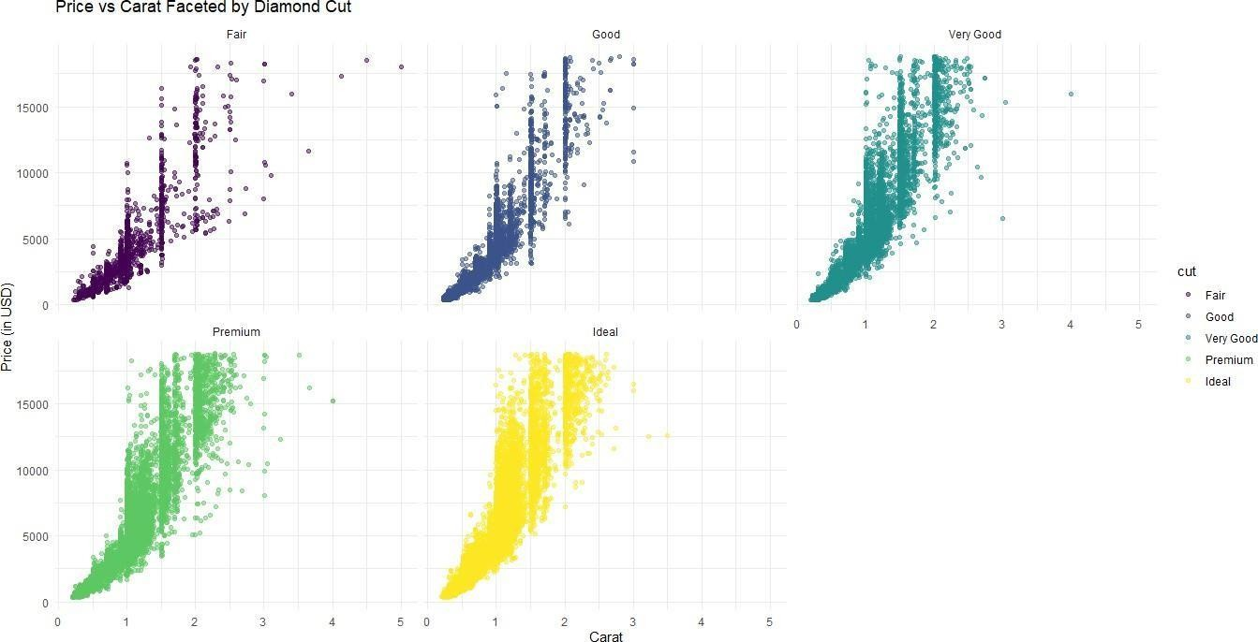

- ggplot(data=diamonds, aes(x=carat, y=price)) +

+ | geom_point(aes(color=cut), alpha=0.5) + # Color points by 'cut'
+ | facet_wrap(~cut) + # Facet by the cut
+ | labs(title="Price vs Carat Faceted by Diamond Cut",
+ | x="Carat",
+ | y="Price (in USD)") +
+ | theme_minimal()

Exploratory Data Analysis # Practical No: 8

Name |  | Roll No: | 46
Class | T.Y.B.Sc. Data Science | Seat Number:
Subject / Topic | Exploratory Data Analysis
Topic | Five number summary in exploratory data analysis.

Practical No: 8 Five number summary in exploratory data analysis.

Code:
# 1. Load the MASS package and Boston dataset library(MASS)
data(Boston)

# 2. Display the first few rows of the dataset to get an overview head(Boston)

# 3. Perform the Five-Number Summary for the 'medv' (Median Value of Homes) variable cat("Five-Number Summary for 'medv' in Boston dataset using fivenum():\n") print(fivenum(Boston$medv))

cat("\nFive-Number Summary for 'medv' using summary() function:\n") print(summary(Boston$medv))

cat("\nFive-Number Summary for 'medv' using quantile() function:\n") print(quantile(Boston$medv, probs = c(0, 0.25, 0.5, 0.75, 1)))

# 4. Create a Boxplot to visualize the Five-Number Summary cat("\nBoxplot for 'medv' (Median Value of Homes) variable:\n") boxplot(Boston$medv,
main = "Boxplot of Median Value of Homes (medv)",

ylab = "Median Value of Homes ($1000s)", col = "lightblue",
border = "blue")

# 5. Create a Histogram to visualize the distribution of 'medv' cat("\nHistogram for 'medv' (Median Value of Homes) variable:\n") hist(Boston$medv,
main = "Histogram of Median Value of Homes (medv)", xlab = "Median Value of Homes ($1000s)",
col = "lightgreen", border = "darkgreen", breaks = 20)

Output:
- library(MASS)
- data(Boston)
- head(Boston)
crim zn indus chas nox rm age dis rad tax ptratio black lstat medv

1 0.00632 18 2.31 |  |  | 0 0.538 6.575 65.2 4.0900 1 296 |  | 15.3 396.90 4.98 24.0
2 0.02731 | 0 | 7.07 | 0 0.469 6.421 78.9 4.9671 | 2 242 | 17.8 396.90 | 9.14 21.6
3 0.02729 | 0 | 7.07 | 0 0.469 7.185 61.1 4.9671 | 2 242 | 17.8 392.83 | 4.03 34.7
4 0.03237 | 0 | 2.18 | 0 0.458 6.998 45.8 6.0622 | 3 222 | 18.7 394.63 | 2.94 33.4
5 0.06905 | 0 | 2.18 | 0 0.458 7.147 54.2 6.0622 | 3 222 | 18.7 396.90 | 5.33 36.2
6 0.02985 | 0 | 2.18 | 0 0.458 6.430 58.7 6.0622 | 3 222 | 18.7 394.12 | 5.21 28.7
- cat("Five-Number Summary for 'medv' in Boston dataset using fivenum():\n") Five-Number Summary for 'medv' in Boston dataset using fivenum():
- print(fivenum(Boston$medv))
[1] 5.0 17.0 21.2 25.0 50.0
- cat("\nFive-Number Summary for 'medv' using summary() function:\n")

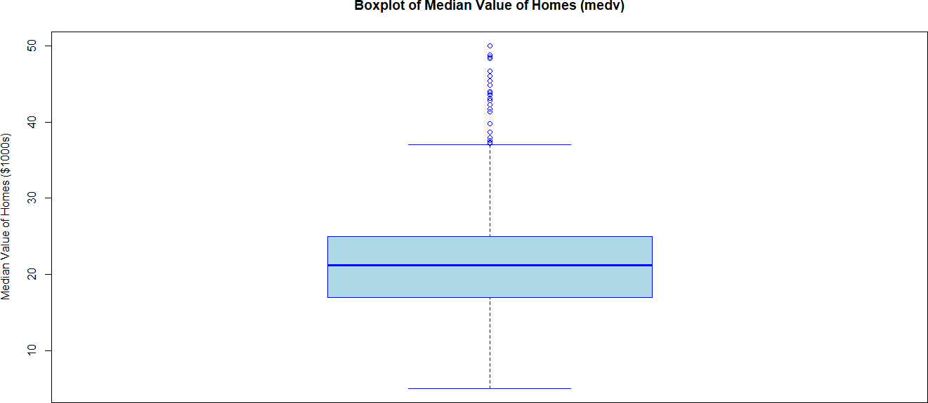
Five-Number Summary for 'medv' using summary() function:
- print(summary(Boston$medv))
Min. 1st Qu. Median Mean 3rd Qu. Max.
5.00 17.02 21.20 22.53 25.00 50.00
- cat("\nFive-Number Summary for 'medv' using quantile() function:\n")

Five-Number Summary for 'medv' using quantile() function:
- print(quantile(Boston$medv, probs = c(0, 0.25, 0.5, 0.75, 1)))
0% 25% 50% 75% 100%
5.000 17.025 21.200 25.000 50.000
- cat("\nBoxplot for 'medv' (Median Value of Homes) variable:\n")

Boxplot for 'medv' (Median Value of Homes) variable:
- boxplot(Boston$medv,
+ main = "Boxplot of Median Value of Homes (medv)",
+ ylab = "Median Value of Homes ($1000s)",
+ col = "lightblue",
+ border = "blue")

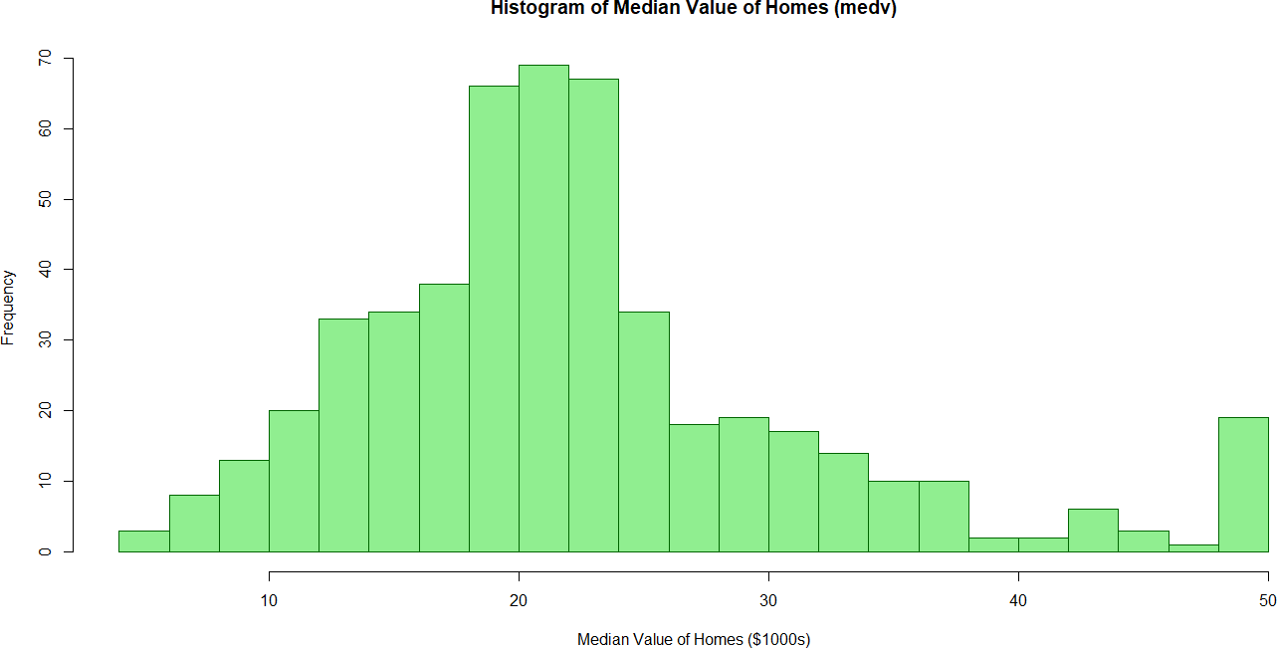
Histogram for 'medv' (Median Value of Homes) variable:
- hist(Boston$medv,
+ main = "Histogram of Median Value of Homes (medv)",
+ xlab = "Median Value of Homes ($1000s)",
+ col = "lightgreen",
+ border = "darkgreen",
+ breaks = 20)

Exploratory Data Analysis # Practical No: 9

Name |  | Roll No:
Class | T.Y.B.Sc. Data Science | Seat Number:
Subject / Topic | Exploratory Data Analysis
Topic | Multiple histogram and multiple boxplots, Multiple scatter plots and colouring  the graph.
Practical No: 9 Multiple histogram and multiple boxplots, Multiple scatter plots and colouring the graph.

Code:
# Load necessary package library(ggplot2)

# Load the iris dataset data(iris)

# --- 1. Multiple Histograms ---
# Set up the plotting area to have 2 rows and 2 columns (4 histograms) par(mfrow = c(2, 2))

# Plot histograms for different variables
hist(iris$Sepal.Length, main = "Histogram of Sepal Length", col = "lightblue", border = "darkblue", xlab = "Sepal Length")
hist(iris$Sepal.Width, main = "Histogram of Sepal Width", col = "lightgreen", border = "darkgreen", xlab = "Sepal Width")
hist(iris$Petal.Length, main = "Histogram of Petal Length", col = "lightpink", border = "darkred", xlab = "Petal Length")
hist(iris$Petal.Width, main = "Histogram of Petal Width", col = "lightyellow", border = "orange", xlab = "Petal Width")

# Reset the plotting area to default (1 plot per page)

par(mfrow = c(1, 1))

# --- 2. Multiple Boxplots ---
# Set up the plotting area to have 2 rows and 2 columns (4 boxplots) par(mfrow = c(2, 2))

# Plot boxplots for different variables by species
boxplot(Sepal.Length ~ Species, data = iris, main = "Boxplot of Sepal Length by Species", ylab
= "Sepal Length", col = c("lightblue", "lightgreen", "lightpink"))
boxplot(Sepal.Width ~ Species, data = iris, main = "Boxplot of Sepal Width by Species", ylab = "Sepal Width", col = c("lightblue", "lightgreen", "lightpink"))
boxplot(Petal.Length ~ Species, data = iris, main = "Boxplot of Petal Length by Species", ylab
= "Petal Length", col = c("lightblue", "lightgreen", "lightpink"))
boxplot(Petal.Width ~ Species, data = iris, main = "Boxplot of Petal Width by Species", ylab = "Petal Width", col = c("lightblue", "lightgreen", "lightpink"))

# Reset the plotting area to default (1 plot per page) par(mfrow = c(1, 1))

# --- 3. Multiple Scatter Plots (Base R) ---
# Set up the plotting area to have 2 rows and 2 columns (4 scatter plots) par(mfrow = c(2, 2))

# Plot scatter plots between different pairs of variables
plot(iris$Sepal.Length, iris$Petal.Length, main = "Sepal Length vs Petal Length", xlab = "Sepal Length", ylab = "Petal Length", col = as.factor(iris$Species))
plot(iris$Sepal.Width, iris$Petal.Width, main = "Sepal Width vs Petal Width", xlab = "Sepal Width", ylab = "Petal Width", col = as.factor(iris$Species))
plot(iris$Sepal.Length, iris$Sepal.Width, main = "Sepal Length vs Sepal Width", xlab = "Sepal Length", ylab = "Sepal Width", col = as.factor(iris$Species))
plot(iris$Petal.Length, iris$Petal.Width, main = "Petal Length vs Petal Width", xlab = "Petal Length", ylab = "Petal Width", col = as.factor(iris$Species))

# Reset the plotting area to default (1 plot per page) par(mfrow = c(1, 1))

# --- 4. Multiple Scatter Plots (Using ggplot2) --- # Scatter plots with custom colors using ggplot2

# Sepal Length vs Petal Length
ggplot(iris, aes(x = Sepal.Length, y = Petal.Length, color = Species)) + geom_point() +
ggtitle("Sepal Length vs Petal Length") + xlab("Sepal Length") +
ylab("Petal Length")

# Sepal Width vs Petal Width
ggplot(iris, aes(x = Sepal.Width, y = Petal.Width, color = Species)) + geom_point() +
ggtitle("Sepal Width vs Petal Width") + xlab("Sepal Width") +
ylab("Petal Width")

# Sepal Length vs Sepal Width
ggplot(iris, aes(x = Sepal.Length, y = Sepal.Width, color = Species)) + geom_point() +
ggtitle("Sepal Length vs Sepal Width") + xlab("Sepal Length") +
ylab("Sepal Width")

# Petal Length vs Petal Width

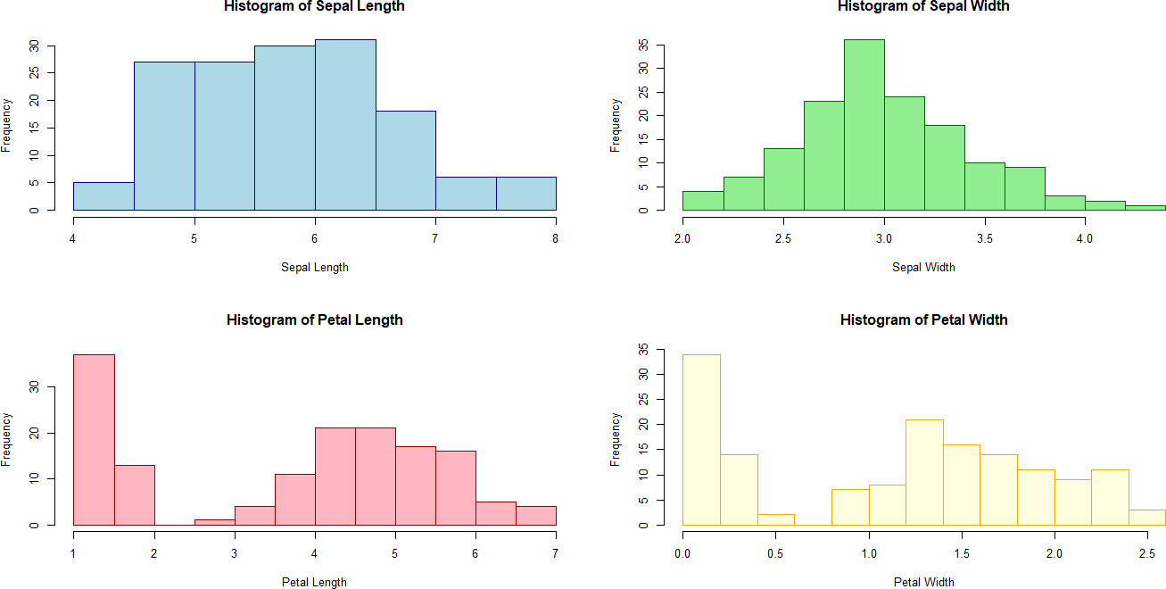
ggplot(iris, aes(x = Petal.Length, y = Petal.Width, color = Species)) + geom_point() +
ggtitle("Petal Length vs Petal Width") +
xlab("Petal Length") + ylab("Petal Width")

Output:
- library(ggplot2)
- data(iris)
- par(mfrow = c(2, 2))
- hist(iris$Sepal.Length, main = "Histogram of Sepal Length", col = "lightblue", border = "darkblue", xlab = "Sepal Length")
- hist(iris$Sepal.Width, main = "Histogram of Sepal Width", col = "lightgreen", border = "darkgreen", xlab = "Sepal Width")
- hist(iris$Petal.Length, main = "Histogram of Petal Length", col = "lightpink", border = "darkred", xlab = "Petal Length")
- hist(iris$Petal.Width, main = "Histogram of Petal Width", col = "lightyellow", border = "orange", xlab = "Petal Width")

- par(mfrow = c(1, 1))
- par(mfrow = c(2, 2))

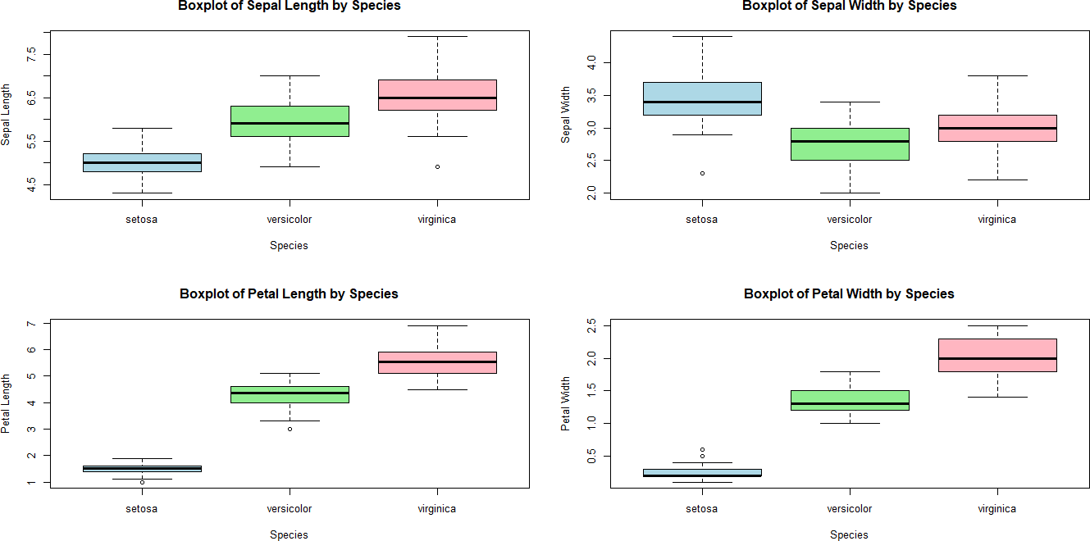
- boxplot(Sepal.Length ~ Species, data = iris, main = "Boxplot of Sepal Length by Species", ylab = "Sepal Length", col = c("lightblue", "lightgreen", "lightpink"))
- boxplot(Sepal.Width ~ Species, data = iris, main = "Boxplot of Sepal Width by Species", ylab
= "Sepal Width", col = c("lightblue", "lightgreen", "lightpink"))
- boxplot(Petal.Length ~ Species, data = iris, main = "Boxplot of Petal Length by Species", ylab = "Petal Length", col = c("lightblue", "lightgreen", "lightpink"))
- boxplot(Petal.Width ~ Species, data = iris, main = "Boxplot of Petal Width by Species", ylab
= "Petal Width", col = c("lightblue", "lightgreen", "lightpink"))

- par(mfrow = c(1, 1))
- par(mfrow = c(2, 2))
- plot(iris$Sepal.Length, iris$Petal.Length, main = "Sepal Length vs Petal Length", xlab = "Sepal Length", ylab = "Petal Length", col = as.factor(iris$Species))
- plot(iris$Sepal.Width, iris$Petal.Width, main = "Sepal Width vs Petal Width", xlab = "Sepal Width", ylab = "Petal Width", col = as.factor(iris$Species))
- plot(iris$Sepal.Length, iris$Sepal.Width, main = "Sepal Length vs Sepal Width", xlab = "Sepal Length", ylab = "Sepal Width", col = as.factor(iris$Species))
- plot(iris$Petal.Length, iris$Petal.Width, main = "Petal Length vs Petal Width", xlab = "Petal Length", ylab = "Petal Width", col = as.factor(iris$Species))

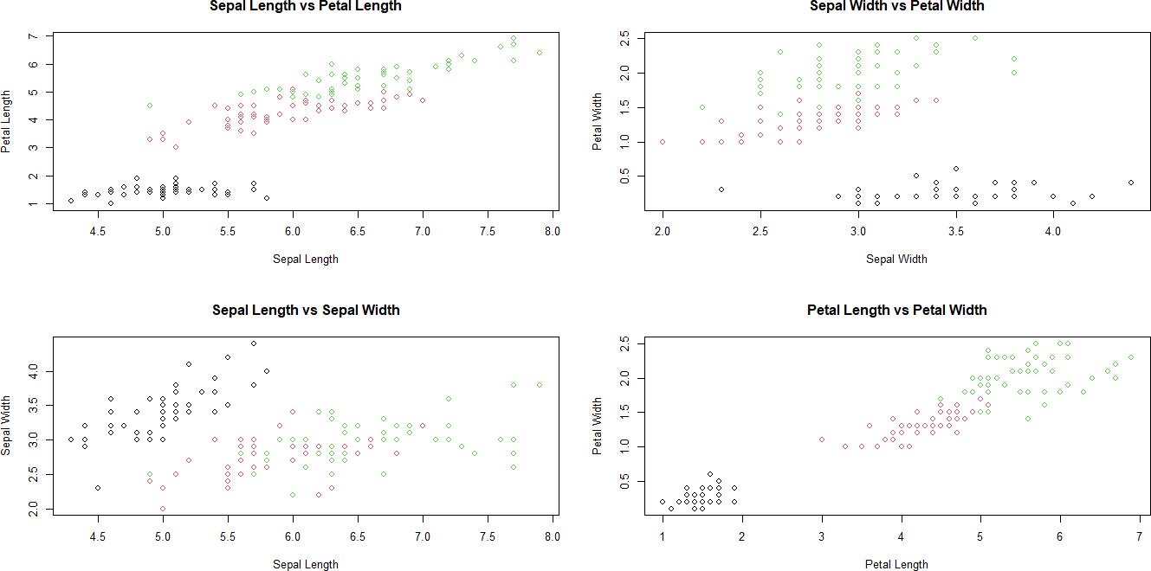
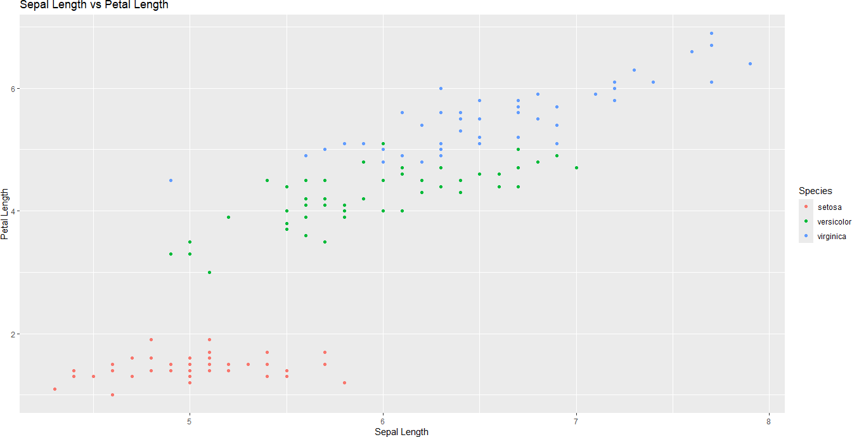

- par(mfrow = c(1, 1))
- ggplot(iris, aes(x = Sepal.Length, y = Petal.Length, color = Species)) +
+ geom_point() +
+ ggtitle("Sepal Length vs Petal Length") +
+ xlab("Sepal Length") +
+ ylab("Petal Length")

- ggplot(iris, aes(x = Sepal.Width, y = Petal.Width, color = Species)) +
+ geom_point() +
+ ggtitle("Sepal Width vs Petal Width") +

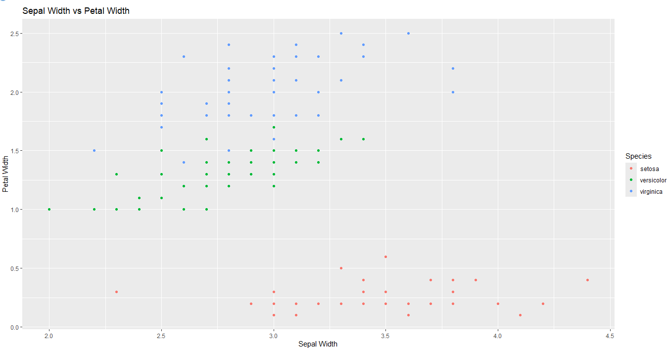
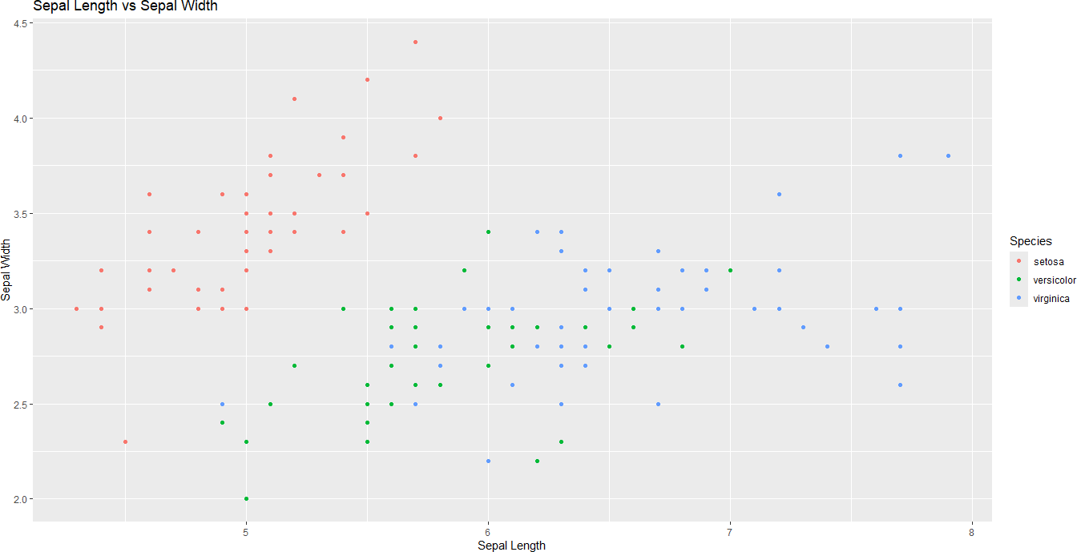
+ xlab("Sepal Width") +
+ ylab("Petal Width")

- ggplot(iris, aes(x = Sepal.Length, y = Sepal.Width, color = Species)) +
+ geom_point() +
+ ggtitle("Sepal Length vs Sepal Width") +
+ xlab("Sepal Length") +
+ ylab("Sepal Width")

- ggplot(iris, aes(x = Petal.Length, y = Petal.Width, color = Species)) +
+ geom_point() +

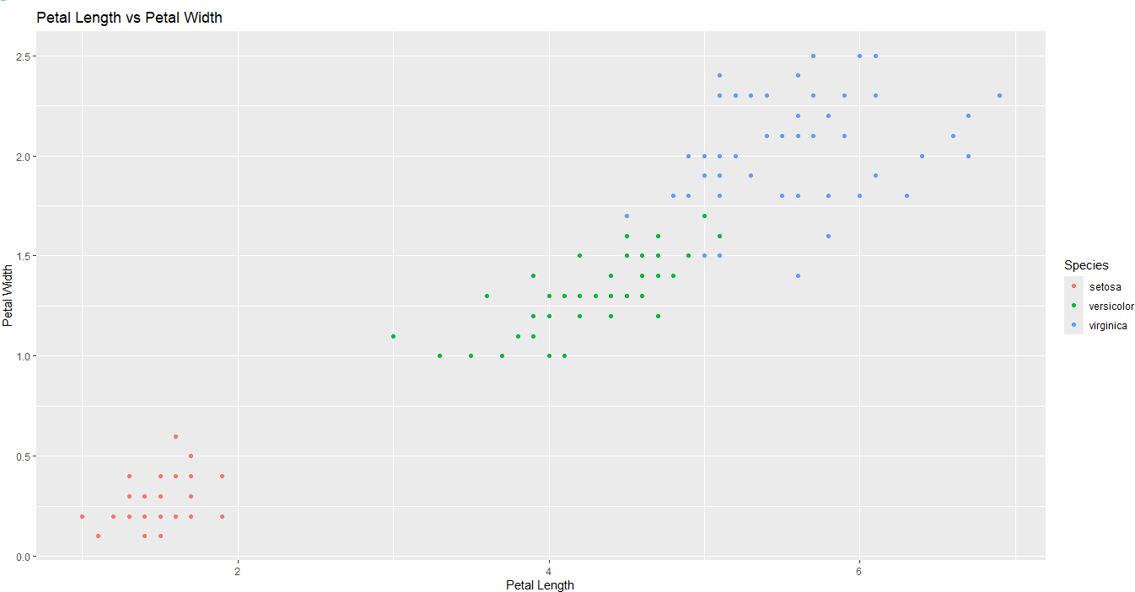
+ ggtitle("Petal Length vs Petal Width") +
+ xlab("Petal Length") +
+ ylab("Petal Width")

Exploratory Data Analysis # Practical No: 10

Name |  | Roll No: | TTyypTpeyeypyoeouyurortueterxxttet xt
Class | T.Y.B.Sc. Data Science | Seat Number:
Subject / Topic | Exploratory Data Analysis
Topic | Lattice system in R environment and Graphical window in R and its uses.

Practical No: 10 Lattice system in R environment and Graphical window in R and its uses.

Code:
# Install and load required packages
if (!require(titanic)) install.packages("titanic") library(titanic)

if (!require(lattice)) install.packages("lattice") library(lattice)

# Load Titanic dataset data("titanic_train")

# Check for missing values in 'Sex' column sum(is.na(titanic_train$Sex)) # Check if 'Sex' has missing values

# Remove rows with NA values in the selected columns for plotting
titanic_train_clean <- na.omit(titanic_train[, c("Age", "Fare", "Survived", "Pclass", "Sex")])

# View first few rows of the dataset head(titanic_train_clean)

# Ensure 'Sex' is treated as a factor

titanic_train_clean$Sex <- factor(titanic_train_clean$Sex)

# Scatter plot: Age vs Fare conditioned by survival status xyplot(Age ~ Fare | factor(Survived), data = titanic_train_clean,
main = "Age vs Fare by Survival Status", xlab = "Fare", ylab = "Age",
type = c("p", "r"), layout = c(1, 2))

# Box plot: Fare by Pclass (passenger class) bwplot(Fare ~ factor(Pclass), data = titanic_train_clean,
main = "Boxplot of Fare by Passenger Class", xlab = "Passenger Class", ylab = "Fare")

# Histogram of Age, conditioned by survival status histogram(~Age | factor(Survived), data = titanic_train_clean,
main = "Histogram of Age by Survival Status", xlab = "Age", col = "lightblue")

# Bar plot of survival count by Sex (Explicit column reference) barchart(table(titanic_train_clean$Sex, titanic_train_clean$Survived),
main = "Survival Count by Sex", xlab = "Sex", ylab = "Count", auto.key = TRUE)

# Pairwise scatter plots for selected variables (Age, Fare, Pclass) splom(~titanic_train_clean[, c("Age", "Fare", "Pclass")],
main = "Pairwise Scatter Plots of Age, Fare, and Pclass")

# Additional: Box plot of Age by Pclass (passenger class) bwplot(Age ~ factor(Pclass), data = titanic_train_clean,
main = "Boxplot of Age by Passenger Class", xlab = "Passenger Class", ylab = "Age")

Output:
- library(titanic)
- library(lattice)
- data("titanic_train")
- sum(is.na(titanic_train$Sex)) # Check if 'Sex' has missing values
[1] 0
- titanic_train_clean <- na.omit(titanic_train[, c("Age", "Fare", "Survived", "Pclass", "Sex")])
- head(titanic_train_clean)
Age Fare Survived Pclass Sex
1 22 7.2500 0 3 male
2 38 71.2833 1 1 female
3 26 7.9250 1 3 female
4 35 53.1000 1 1 female
5 35 8.0500 0 3 male
7 54 51.8625 0 1 male
- titanic_train_clean$Sex <- factor(titanic_train_clean$Sex)
- titanic_train_clean$Sex <- factor(titanic_train_clean$Sex)
- xyplot(Age ~ Fare | factor(Survived), data = titanic_train_clean,
+ main = "Age vs Fare by Survival Status",
+ xlab = "Fare", ylab = "Age",
+ type = c("p", "r"),
+ layout = c(1, 2))

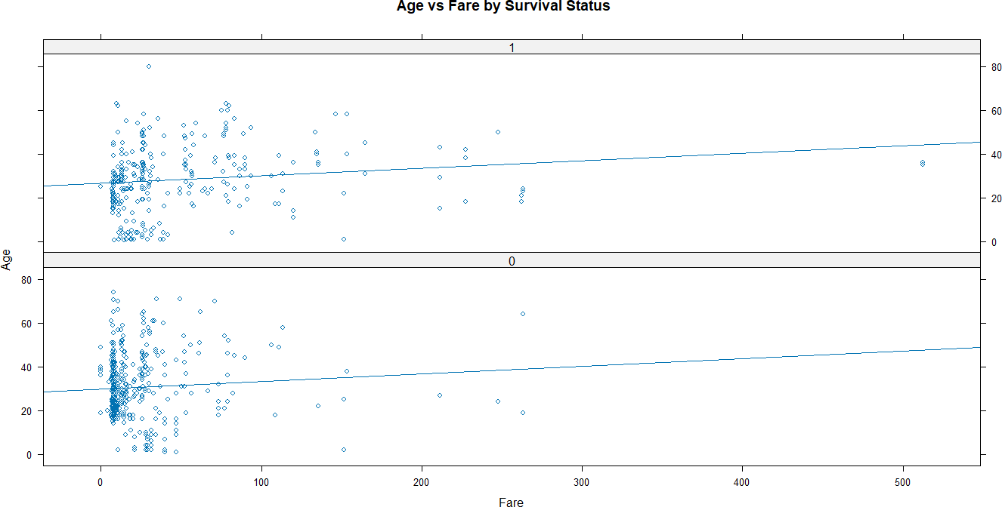
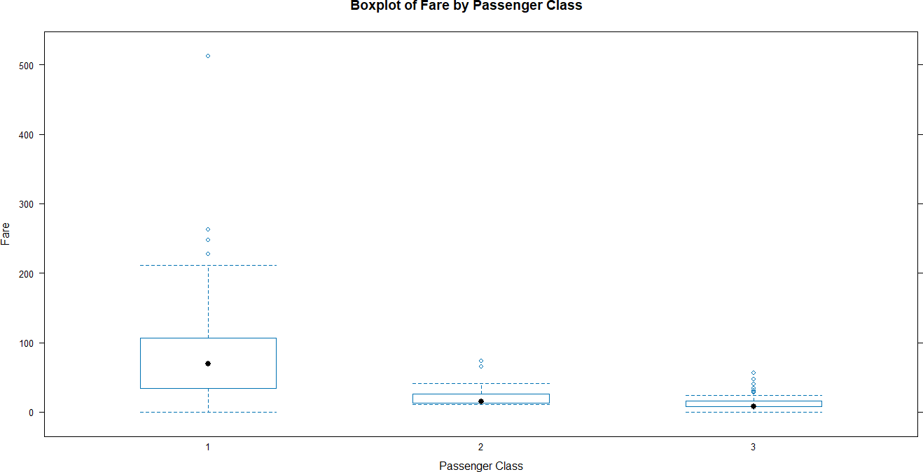

- bwplot(Fare ~ factor(Pclass), data = titanic_train_clean,
+ main = "Boxplot of Fare by Passenger Class",
+ xlab = "Passenger Class", ylab = "Fare")

- histogram(~Age | factor(Survived), data = titanic_train_clean,
+ main = "Histogram of Age by Survival Status",
+ xlab = "Age", col = "lightblue")

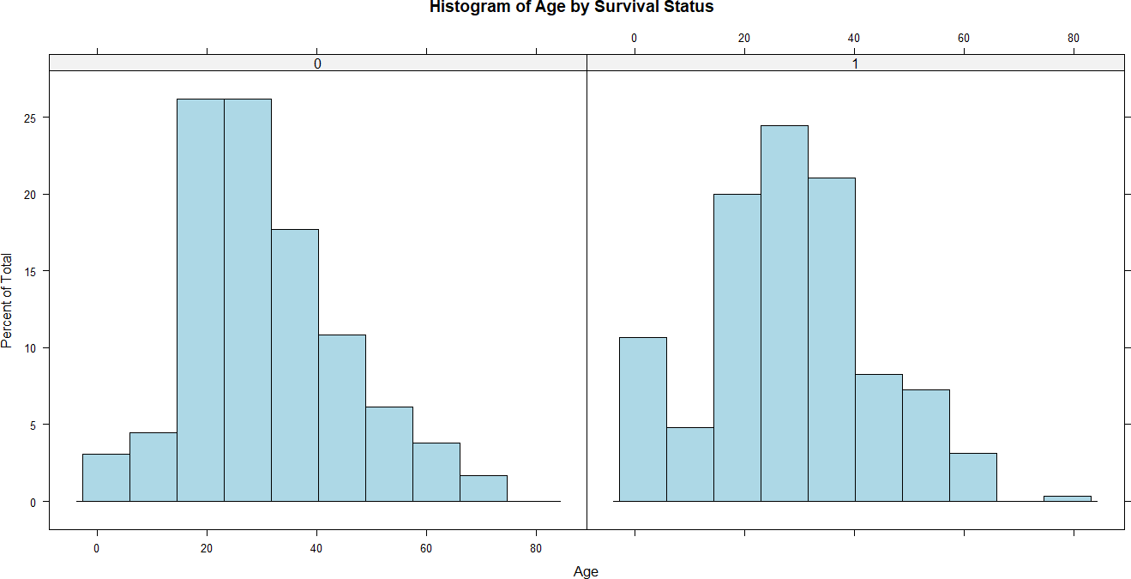
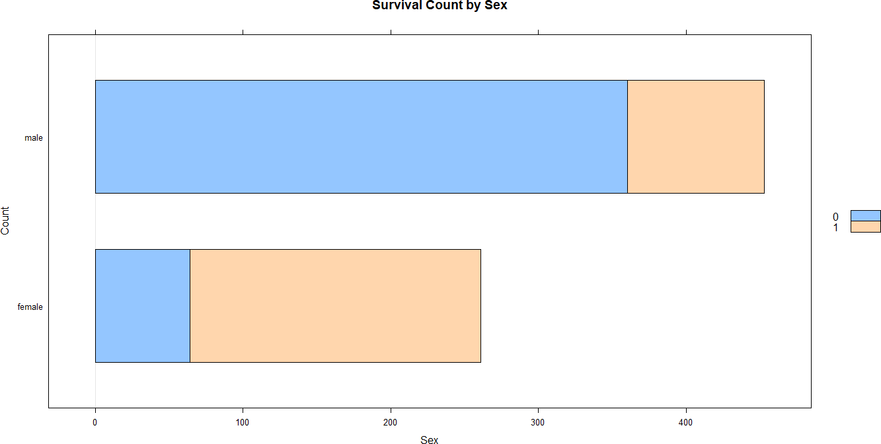

- barchart(table(titanic_train_clean$Sex, titanic_train_clean$Survived),
+ main = "Survival Count by Sex",
+ xlab = "Sex", ylab = "Count",
+ auto.key = TRUE)

- splom(~titanic_train_clean[, c("Age", "Fare", "Pclass")],
+ main = "Pairwise Scatter Plots of Age, Fare, and Pclass")
- bwplot(Age ~ factor(Pclass), data = titanic_train_clean,
+ main = "Boxplot of Age by Passenger Class",
+ xlab = "Passenger Class", ylab = "Age")

